e-ISSN: 2456-3463
International Journal of Innovations in Engineering and Science, Vol. 2, No.1, 2019 www.ijies.net

ONLINE PARKING SYSTEM

Aayush Gheoday1, Nagarjun Raut2, Prajakta Kshirsagar3, Dhanashree Gaikwad4.

Ms. Nikita Hatwar, Asst. Professor

Priyadarshini College of Engineering, Nagpur, India, 441110

ABSTRACT- With the increase of economical behavior and the upgrade of living standard of people, the ratio of people who own cars and motorcycles have recently increased giving a boost to Metropolitan Traffic. This result in the increase of the personal vehicle usage. People prefer personal vehicles to commute than depend on public transportation. Now a days parking issues will be a big challenge to facilitate traffic network and ensure the urban life quality. Finding a parking space in most metropolitan areas, especially during the rush hours, is difficult for drivers. The difficulty arises from not knowing where the available spaces may be at that time or not; even if known, many vehicles like two wheeler and four wheeler may pursue very limited parking spaces to cause serious traffic congestion. Due to this there is a need to provide sufficient parking places coupled with plenty of slots to help the user park his vehicle safely, also to ensure the user does not end up parking on non-parking area and cause discomfort to pedestrian. Online parking system provides user an easy way of booking the parking slots through an application. To avoid the problem of traffic conjunction in commercial areas that unnecessarily consumes time, this paper provides the easy reservation system for parking. This application relieves the user from the hassle of manually searching and waiting for empty slots to park the vehicle.

INTRODUCTION- Android is an operating system, developed for mobile devices like Smartphone’s and tablet computer, which is based on Linux operating system. It was developed by Google in the year 2005. It is the Smartphone platform. Searching for the vacant parking space in a metropolitan area is the daily concern for most the drivers, and it is time consuming. It commonly results more traffic congestion and air pollution by constantly cruising in certain area only for an available parking space. For an instance, a recent survey shows that during rush hours in most of big cities, the traffic generated by cars searching for parking spaces takes up to 40% of the total traffic on that particular road. To alleviate such traffic congestion and improve the convenience for drivers, many of smart parking systems aiming to satisfy the involved parties (e.g., parking service providers have been deployed. The current smart parking or parking guidance systems only obtain the available information of parking spaces database which is managed by reservation authority and simply display the parking information to direct drivers or user. However, since these type of systems cannot guide the drivers to their particular parking destinations, even sometimes make the situation worse, they are not “smart” enough. For instance, when the number of vacant spaces in an area is limited, most of drivers, who obtain the parking information, are heading for these spaces. It will cause server congestion. It is, therefore important, strongly desired to provide an effective strategy to address these concerns. In this application the user can view various parking slots and check for the availability of slots. Whenever a user books a particular slot it will be marked red and all the available slots will be green. By periodically learning the parking status from the host parking database management in parking lot, the reservation service is affected by the change of physical parking status.
METHODOLOGY- The slot allocation method follows a sequence as stated below:
Step1: Initially the slot selection is made by the user from his mobile phone. He checks for the availability of a parking slot that is nearest to his location. If it is available, he moves to the next stage or else go to the initial state.
Step2: Transfers request for parking slot from the mobile using Android application.
Step3: The Parking Control Unit (PCU) gets the slot number requested by the user.
Step4: If the payment is done successfully, then the requested slot is reserved in the parking area.
Step5: After reserving a particular slot by the user then the status of that respective slot will be marked as RED=RESERVED and the remaining will be GREEN=EMPTY.
Step6: As soon as the vehicle gets entered into the parking slot, the timer gets ON and measures the total time.
Step7: As soon as the vehicle moves out of the parking slot, the timer gets OFF

DESIGN-
Client Side
Initially the user need to install IPS application on his android device. After installation the IPS icon will be displayed on his android mobile screen. Registration and login: If the user is a new user he needs to get registered with the application by giving all his details. The data which is entered by the user is stored on the server. These details consists user name, email, password, address etc. This registration is done only for the first time. After successful registration he receives a unique login ID both to his mobile and mail. After the user gets registered with the application, the user can login by providing email and unique ID. User gets this unique ID both to user’s mail and mobile number as soon as he gets registered. If the user gets successfully login to the application then the user is said to be an authorized user.

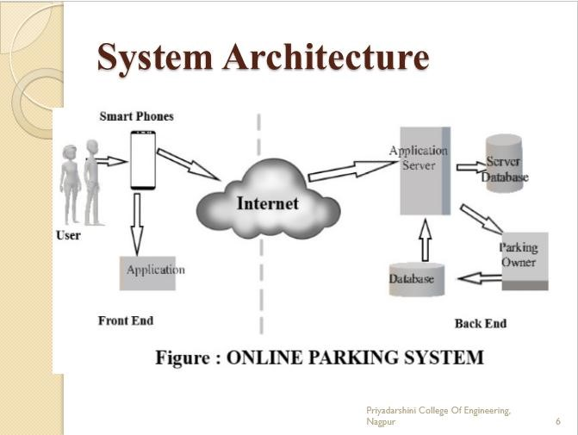

Check for a slot and its status:
User login the application where he can view various parking slots in his destination location. User selects his desired parking slot that is nearest to his destination. After selecting a slot the user needs to check for the availability of that respective slot. The user can check the status of the slots with the help of green and red colour indications. Where green colour indicates that the respective slot is empty and the red colour indicates that the respective slot is already allocated to some other user.

CONCLUSION- If it is a dwelling, entertainment centre or a market place, the first and foremost question in the minds of everyone is about the parking slot. Compared to other developed countries, the problem of parking is disheartening in India as there is no well devised plan in place. There is a wide gap and total mismatch between the production of vehicles and the parking slots. Government authorities have been raking their brains day in and day out to tackle this problem. The parking problem is quite acute in places of entertainment such as theatres and shopping malls. We touched a small scenario of parking problem in India in this paper. We brought out in this paper how the parking problem in such places can be tackled with a well-thought plan. The plan helps both the visitors and administrators. It helps the visitors in finding out the availability of a parking slot, get the availability confirmed, and reach the place within the time slot allotted. It helps the administration to allocate the vacant slot to the next person in queue. A well thought parking plan saves the time of visitors in booking a parking slot in advance and the administration to allocate the vacant slot in a methodical and organized manner

REFERENCES-
- Faiz Ibrahim Shaikh, Pratik Nirnay Jadhav, Saideep Pradeep
Bandarkar, Omkar Pradip Kulkarni, Nikhilkumar B. Shardoor “Smart
Parking System Based on Embedded System and Sensor Network”,
International Journal of Computer Applications (0975 – 8887)
Volume 140 – No.12, April 2016 International Journal of Pure and
Applied Mathematics Special Issue 171
- Thanh Nam Pham1, Ming-Fong Tsai1, Duc Binh Nguyen1, Chyi-
Ren Dow1, And Der-Jiunn Deng2 “A Cloud-Based Smart-Parking
System Based on Internet-of-Things Technologies”,IEEE Access, Received July 24, 2015, accepted August 16, 2015, date of publication September 9, 2015, date of current version September 23, 2015.
- El Mouatezbillah Karbab, Djamel Djenouri, Sahar Boulkaboul, Antoine Bagula, CERIST Research Center, Algiers, Algeria
University of the Western Cape, Cape town, South Africa,”Car Park
Management with Networked Wireless Sensors and Active
RFID”„,978-1-4799-8802-0/15 ©2015 IEEE
- Mr. Basavaraju S R “Automatic Smart Parking System using
Internet of Things (IOT)”, (International Journal of Scientific and Research Publications, Volume 5, Issue 12, December 2015)
- M. M. Rashid, A. Musa, M. Ataur Rahman, and N. Farahana, A.
Farhana, “Automatic Parking Management System and Parking Fee
Collection Based on Number Plate Recognition.”, International Journal of Machine Learning and Computing, Vol. 2, No. 2, April 2012, Published 2014.
- Hilal Al-Kharusi, Ibrahim Al-Bahadly, “Intelligent Parking Management System Based on Image Processing”, World Journal of Engineering and Technology, 2014, 2, 55-67.
- X. Zhao, K. Zhao, and F. Hai, ``An algorithm of parking planning for smart parking system,'' in Proc. 11th World Congr. Intell. Control Autom. (WCIC A), 2014, pp. 4965_4969.
- L. Mainetti, L. Palano, L. Patrono, M. L. Stefanizzi, and R. Vergallo, ``Integration of RFID and WSN technologies in a smart parking system, ''in Proc. 22nd Int. Conf. Softw., Telecommun. Comput. Netw. (Soft COM), 2014, pp. 104_110.
- Harmeet Singh, Chetan Anand, Vinay Kumar, Ankit Sharma,
“Automated Parking System With Bluetooth Access”, International
Journal Of Engineering And Computer Science ISSN:2319-
7242,Volume 3 Issue 5, May 2014, Page No. 5773-5775
- C. Shiyao, W. Ming, L. Chen, and R. Na, ``The research and implement of the intelligent parking reservation management system based on ZigBee technology,'' in Proc. 6th Int. Conf. Meas. Technol. Mechatronics Autom. (ICMTMA), 2014, pp. 741_744.

