Design & Analysis of Beam-Column Structures with Nonlinear Supports& Computer program

Anchala Singh Markam
Dr. Rakesh Pandey
MATS SCHOOL OF ENGINEERING & INFORMATION TECHNOLOGY, Raipur, India, 492001

Email of corresponding Author:

Received on: xxxx,20xx, Revised on: xxxx,20xx, Published on: xxxx,20xx

Abstract – This paper will be helpful for researchers for method selection design validation of beam column structures with nonlinear support and computer program, technique for computer-aided design and analysis of beam-columns under various load with nonlinear support

To ease numerical solutions of complicated structural elements, the approach employs discrete-element mechanical models of continuous parts. The axial and lateral solutions are linked to account for the impact of axial forces on the bending behavior of the member.

The members are designed for maximum Tension and Compression load for the most critical load combination as per code IS 2062, IS802 & IS 1852. The Seismic behavior of the Beam and column structure for factory shed has been tabulated and the deflections, axial forces, modal time period and base shear of both types of method are noted and comparison between computer analysis, numerical analysis & experimental analysis.

Keywords- Computer Programing, Numerical Method, Experimental Method, Design validation, Mechanical Structure, Displacement load.

INTRODUCTION
A number of difficulties involving beam-column type members exist, for which there are no suitable mathematical solutions. These include axially and laterally loaded piles with nonlinear supports, beams with variable cross-sections or resting on closely spaced dispersed supports, and elastic buckling of columns with varied cross-sections or with distributed nonlinear supports. The programmable computer programmer for analyzing beam column members under combined axial and lateral stresses with nonlinear support has been

created, the effected of internal axial forces on bending behaviors are investigated.
A computer program for analysis of general beam-column structures supported and/or loaded by components which interact with displacements of the beam and/or column the computer program described in this report has been checked to ensure that the results are accurate within the limitations of the procedures employed. However, there may be unusual situations which were not anticipated, and these situations may cause the program to produce questionable results. It is the responsibility of the user to judge the validity of the results. No responsibility is assumed by the author for the design or behavior of any structure based on results obtained with the program. Describes the general beam- column system considered and the mathematical model used for analysis. Presents the force- displacement relationships for the mathematical model and describes the computational procedure used for the solution.

HOW ARE BEAMS AND COLUMNS USED IN A STRUCTURE?
Columns and beams are two fundamental structural elements that are essential to stability. They support the weight of the building and create a safe load path, transferring the weight and forces applied to the structure of the building to the foundation and the ground.

Uses: Light Gauge Steel Framing Prefabricated Hall Building / Factory / Shed Steel Structure Drawing, Find Complete Details about Light Gauge Steel Framing Prefabricated Hall Building / Factory / Shed etc.

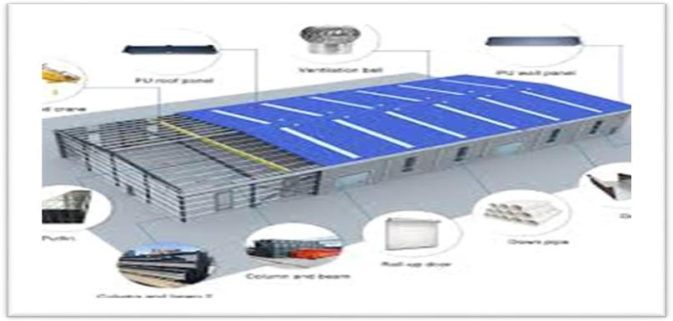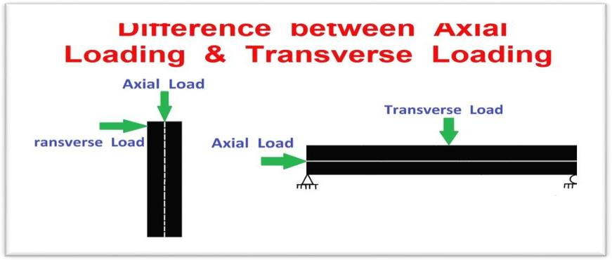

Fig: Beam and Column Steel Structure

OBJECTIVES

- To study the nonlinear response of corner beam- column junctions with inclusion of the effect of construction joint between the column and the beam fabricated at different times and subjected to cyclic and repeated loads, a computer program of three dimensional nonlinear finite element analysis.
- A parametric study dealing with fabricated joint is presented by taking various conditions of the junction. These include the axial load on the column, strength of joint in the second cast.
- An important result from the research done so far is that the notion of a rigid joint can be discarded forever. Thus, just as beams, columns and other structural elements exhibit flexibility in response to applied loading.
- Comparison Study with help of Computer programing, Numerical method & Experimental Method and Design Validation.

METHODOLOGY

- Mechanical Model Development
- Computer Base Analysis
- Numerical Method
- Experimental Method

GENERAL ANALYSIS REQUIREMENTS OF COLUMN AND BEAM STEEL STRUCTURES
- Transverse Load
- Longitudinal Load
- Torsional shear Load
- Self-weight
- Wind Load
Fig: Difference types of Load

MECHANICAL MODEL DEVELOPMENT

When the need for a new structure arises, an individual or agency has to arrange the funds required for its construction. The individual or agency henceforth referred to as the owner then approaches an architect. The architect plans the layout so as to satisfy the functional requirements and also ensures that the structure is aesthetically pleasing and economically feasible. In this process, the architect often decides the material and type of construction as well. The plan is then given to a structural engineer who is expected to do locate the structural elements so as to cause least interference to the function and aesthetics of the structure. He then makes the strength calculations to ensure safety and serviceability of the structure. This process is known as structural design. Finally, the structural elements are designed in 3D model with help of computer programming.

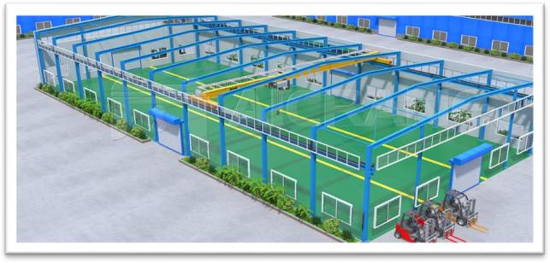
Fig: 3D Model

COMPUTER BASE ANALYSIS MAIN STEPS

- Entering job information.
- Building model geometry
- Defining member properties, sections.
- Assigning loads (load cases, combinations...)
- Defining pre-analysis print out, analysis type, and post-analysis printout.
- Defining design requirements
- Apply the load

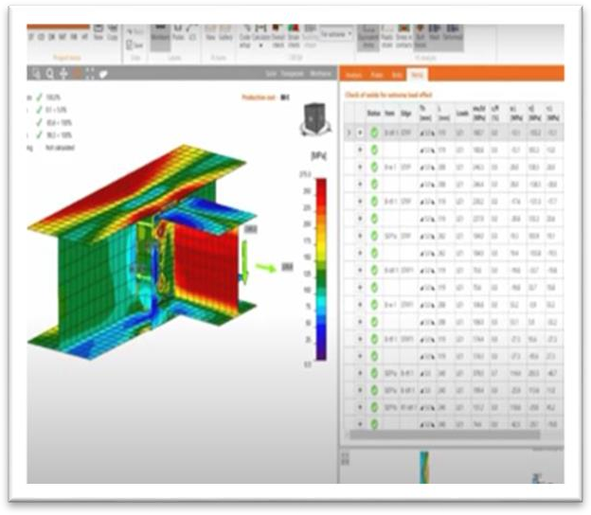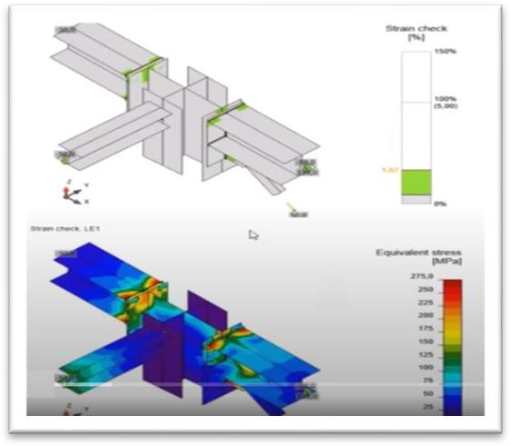

Fig: Load Analysis

No | Material | Yield Result (N/mm2) | Deflection Value (mm)
1 | BEAM | 511
 | 152 X 203
 |  |  | Welded
2 | SC 250 | 549 | Joint
Deflection
3.25 MM
3 | SC 225 | 449
4 | Plate 20 MM | 546
5 | Plate 10 MM | 526

NUMERICAL METHOD

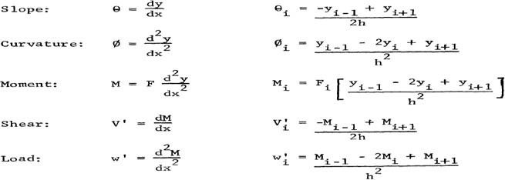

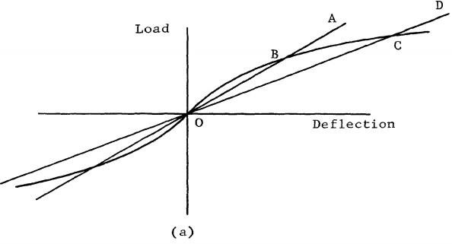

Fig: Numerical Method

No | Material | Yield Result (N/mm2) | Deflection Value (mm)
1 | BEAM | 510
 | 152 X 203
 |  |  | Welded
2 | SC 250 | 551 | Joint
Deflection
3.24 MM
3 | SC 225 | 500
4 | Plate 20 MM | 546
5 | Plate 10 MM | 525

EXPERIMENTAL METHOD

The detailed process for Experimental Testing

- First assemble the steel structure as shown in figure.1with with help of Manpower and crane
- After that Hanging the Wire rope with load cell, load cell connected with control room.
- Applied the load according load chart with help of control room controller
- Note down the load and deflection of Steel Structure in your note pad as per table 1

- Deflection measured by Total station machine on each node of element and load measure by load meter
- Once the all load applied on the Steel structure according to load chart & the tower will standing itself within the limit , then testing was passes
- Where the deflection is more we can check that element yield load by practically by using Universal testing machine as per table no. 1.
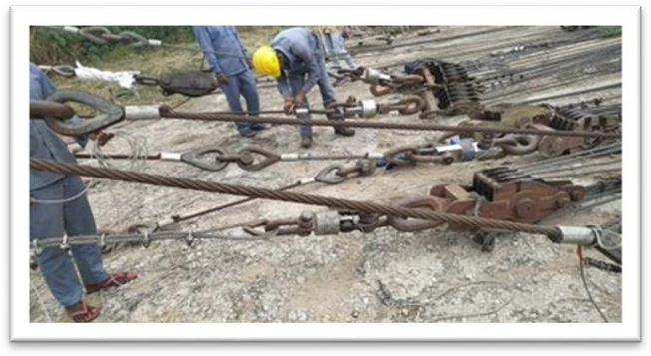

Fig: Hanging of load cell with wire
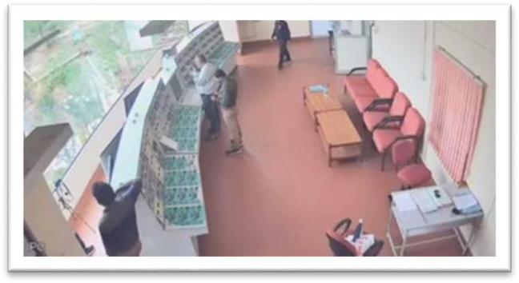

Fig: Experimental Testing setup

Table 1: Experimental Testing Tower Structure yield load and deflection as per below

No | Material | Yield Result (N/mm2) | Experimental Deflection Value (mm)
1 | BEAM | 511
 | 152 X 203
 |  |  | Welded
2 | SC 250 | 550 | Joint
 |  |  | Deflection 3 MM
3 | SC 225 | 499
4 | Plate 20 MM | 547
5 | Plate 10 MM | 526

RESULTS AND DISCUSSION

Statistical Comparison between Experimental, Computer-based Analysis, Analytical Calculation
Table: Experimental Testing Tower Structure yield load and deflection as per below

S N | Material  /Joint | Experimental Result |  | Numerical Result |  | Computer Based Analysis
 |  | Yiel d Res ult (N/ mm 2) | Deflect ion Value (mm) | Yiel d Res ult (N/ mm 2) | Deflect ion Value (mm) | Yiel d Res ult (N/ mm 2) | Deflect ion Value (mm)
1 | BEAM | 511 | Welded | 510 | Welded | 511 | Welded
 | 152 X  203 |  | Joint Deflect ion |  | Joint Deflect ion |  | Joint Deflect ion
2 | SC 250 | 550 | 3 MM | 551 | 3.24 | 549 | 3.25
 |  |  |  |  | MM |  | MM
3 | SC 225 | 499 |  | 500 |  | 449
4 | Plate 20 | 547 |  | 546 |  | 546
 | MM
5 | Plate 10 | 526 |  | 525 |  | 526
 | MM

The computer program described in this report has been checked to ensure that the results are accurate within the limitations of the procedures employed. However, there may be unusual situations which were not anticipated, and these situations may cause the program to produce questionable results. It is the responsibility of the user to judge the validity of the results. No responsibility is assumed by the author for the design or behavior of any structure based on results obtained with the program

The results are performed in three ways i.e. in experimental basis and validate by using software testing including Analytical. The above table shows that the test which is conducted by applying various at different element as mentioned in the previous chapter. The results are obtained under specially test vision persons. The horizontally and vertically assembly of test prototype was inspected and steel structure was erected on the factory premises successfully.

Similarly it is test by using virtual software. This is the well-known software used in the industry for structural analysis and many more type of analysis. as per element. And here also results are within the safe zone. Also Analytical calculation done, with reference of Experimental & software basis.

CONCLUSION

The paper was successfully achieved its objectives that is the problems which are occurred in the steel structure are now overdesigned and checked by using all possible parameter which are occurred while installation as well as giving its service life without any catastrophic failure. And it is possible because of team work and support of senior person in this project. It is tested by using experimental technique and validate by using software based modeling technique, for this 3D modeling is design in such a way that the proposed model will not be failed in the future and its fatigue life will be more.

ACKNOWLEDGMENT

Acknowledgment to person or the organization supported to the author for the research work. This is not mandatory for all.

REFERENCES

- IS 802 Code of practice for use of structural steel
- IS 1852 Code of practice for use of structural steel
- IS 2062Code of practice for use of structural steel
- A numerical solution for beam-columns on non-linear foundations , Master Thesis , By Wendelin H. Mueller III
- Detailed Design, 3D Modelling & Costing of MultiStorey
R.C.C Building, Mohammad Khalil Khan1, Lokesh Vardhan D2, Faizan Aslam Khan3, T M Hasibur Rahaman4, Bishal shah5, Sahil Jaggi
- IS Code of Practice for Design Loads (other than earthquake) for Buildings and Structures," IS:875(Part –
III)-2015, B.I.S
- Abe, H., Yamashita, S., Ueda, T., Kimura, H. & Ishikawa, Y. (2006). Experimental study on R/C beam-columns joints with high-strength steel bars SD590: Part 1 outline of experiment, part 2 test results. In Proceedings of Annual Meeting Architectural Institute of Japan (Kanto Chapter) C-2, Structures IV (pp. 19–22). (in Japanese).
- ACI Committee 374. (2005). Acceptance criteria for moment frames based on structural testing and commentary (ACI 374.1-05). American Concrete Institute: Farmington Hills, MI.
- Analysis of exterior beam-column connection on structures of Marrakech suites apartment by using abacus care v6.14 program on the earthquake area 4 Henry Apriyatno1 , Karuniadi Satrijo Utomo2 , M. Samantha Dewi3 1 Universitas Negeri Semarang
- STEEL STRUCTURES DESIGN AND DRAWING (A60130) III B-Tech –II Semester (JNTUH- R15) Mr. B. Suresh Assistant Professor Mr. G. Anil Kumar Assistant Professor

