Literature Survey on Smart Water Quality Monitoring System
Kumar K, Vaishnavi V, Varshitha R C, Tejaswini M, Needhu Rebecca Biju Department of Computer Science and Engineering K S Institute of Technology, Bangalore

Abstract: Water is one of the major compounds that profoundly influence ecosystem. But, nowadays it is been exploited heavily due to rapid industrialization, human waste and random use of pesticides and chemical fertilizers in agriculture, which leads to water contamination. Thus, a water monitoring system is necessary to observe the water quality in a large area such as lake, river, and aquaculture. As per the current world situation, Internet of Things (IoT) and remote sensing techniques are used in heterogeneous areas of research for supervising, congregate and analyzing data from the remote locations. In this paper, the suggested system is a minimal price real time water quality monitoring system in IoT environment. This system comprise of numerous sensors for assessing the physical and chemical parameter. The factors of water that can be assessed using these sensors are pH, turbidity, conductivity, dissolved oxygen. Using this system the real time quality of water bodies can be determined and the data uploaded over the Internet are analyzed.
Key Words: - Water quality, Internet of Things (IoT), Cloud, Wi-Fi, Water parameters
I. INTRODUCTION
India is facing a major issue of natural resource exiguity, especially in case of water due to population growth and economic development. Most of the water bodies are contaminated due to the superfluous pollutants, which are mostly human-made. Thus certify the cleanliness of water is a major challenge. Rapid industrialization and greater emphasis on agriculture growth with latest technology, usage of more c fertilizers and pesticides caused large impurity in aquatic surroundings directing to debasement of water quality and depletion of aquatic life. Water bodies are contaminated due to point and non-point sources of pollution, which include sewage discharge, discharge from industries, run-off from agricultural fields, urban run-off and even due to floods, droughts and lack of education and awareness amid users. The involvement of users in looking at the aspects like hygiene, environment sanitation, storage and disposal are exceptive elements to uphold the quality of water bodies. The

Tonicity of lakes, rivers and other water bodies and their biological diversification are directly linked with the health of nearly every element of the ecosystem. Due to the use of befouled water by ecosystem components, the water borne diseases are spreading over surroundings causing death and slowing down socio-economic progress. About 5 million people have died because of waterborne diseases all over the world (Water Resource Information System of India, 2017). Fertilizers and pesticides used for agriculture purpose can be washed by rain through soil, which ends up in water bodies. Industrial effluents are also washed into water bodies. These pollutants go into the food chain and gather till they reach noxious levels, ultimately killing birds, fish and mammals. For potable water, it should of high quality whereas for agriculture and industries the quality can be flexible. Industries use water from rivers to power machinery and for cooling down machinery Increment in water temperature diminishes the broke down oxygen level in water which influences the biotic life. (Central Ground Water Board, 2017). The large portion of the above variables makes water quality checking more paramount in our biological system.
Water quality observing is the gathering of data from the suggested framework dispatched at the set areas at a standard interim of time, with a precise goal to give the constant information which will be utilized to characterize the ebb and flow conditions. The primary point of constant water quality observing framework incorporates the valuation of water quality parameters, for example, physical, substance properties, with a definite goal to recognize the varieties in water parameters and to give an early cautioning of the dangers. The framework additionally gives a constant examination of the gathered information and recommends reasonable medicinal measures to slacken the water pollution.
The aim of this paper is to deliver a survey of functions held in smart water quality monitoring system with respect to application, communication technology used, sensors used etc. and to portray a minimal price periodic smart water quality monitoring system using a arduino microcontroller with Wi-Fi module to examine parameters like pH, turbidity, temperature, water level, conductivity. The system also takes account of a facility to inform the user and the concerned authorities on variation of parameters in water bodies.
TABLE 1 IDEAL WATER RANGES IN ACCORDANCE WITH WHO STANDARDS
Parameters Monitored | Quality Range | Units
Turbidity | 5-10 | NTU
pH | 6.5-8.5 | pH
Conductivity | 300-800 | microS/cm

II. DEFINITIONS
Water quality refers to chemical, physical biological and radiological characteristics of water. It is a measure of the condition of water relative to the necessities of one or more biotic species and or to any human need or purposes.
Water quality monitoring is defined as a sampling and analysis of the water (lake, stream, ocean and river) and conditions of the water body.
Smart water quality monitoring is a process of real-time monitoring and the analysis of water to identify changes in parameters based on the physical, chemical and biological characteristics.
III. INTERNATIONAL LEVEL OF WATER QUALITY MONITORING SYSTEM
UNITED KINGDOM:
The statistics from a network of buoys in a river or harbour report the water quality to a central computer. This base computer analyses and stores the data, by comparing it with alarm levels set by the Client and background levels from other buoys in different locations. The system cautions the users about the water quality by giving notifications to phone. The system has been used in conjunction with dredgers and can even call the Captain warning him that the dredging is causing poor water quality. The data produced by the system is not valuable in determining patterns of siltation, salinity, healthy for aquatic living environments. The hardware is complimented by a team of surveyors, systems engineers and boatmen to manage the installation, maintenance, calibration and control of the project efficiently.
THAILAND:
Totally there are 28 variables in the National Surface Water Quality Standards. Surface water quality were inspected and fabricated for supervising system program. The program was put into service in 1980. There are two sources for sampling sources: surface and ground waters. There are absolutely 366 stations in 49 rivers within the country. The samples were fetched 3- 4 times a year including wet and dry periods. The method of water sampling and assessment procedures followed the Standard Method for the Examination of Water and Wastewater (1998). The quality assurance/quality control (QA/QC) was also performed during the analysis. PCD has operated 28 automated sampling stations alongside major rivers in the country. Each station processes only the fundamental water quality parameters like temperature, pH, conductivity and DO.
SINGAPORE:
A team at the National University of Singapore led by Teong Beng Koay is developing a smart robotic platform that allows both spatial and chronological monitoring of water quality in Singapore’s freshwater reservoirs. Names NUSwan, the robot is designed to view as a white swan and traverse unmanned across the reservoir surface to perform water quality profiling at locations of interest. The data collected on-board the robot will be pour out in real-time to a command center for efficient dissemination to the operators and the behaviors can be altered by the operators remotely based on the observed data.
The NUSwan carries standard sensors for determining parameters such as dissolved oxygen, turbidity, and blue-green algae. Conjoined with real data delivery, the water body scrutiny, independent spot water sampling and pollutant tracing has the capability to be unified as a part of early cautioning and decision support systems.
FRANCE:
The quality check in the observation stations is exerted either from automatic analysis devices, or by implementation of warning systems. The automatic analysis measures continuously a certain number of general parameters (pH, temperature, resistivity, dissolved oxygen, turbidity) whose variations can indicate a total pollution. When the intensity of certain elements (mercury, chromium, lead, copper, cadmium etc.) exceeds a given rate, a distress signal is set off. There are other warning systems, which relate to the total quality of water, the trout observation, which reacts in a total way to the unit of the polluting elements, contained in water body. These devices still are very rare because of the operational and capital costs which they represent, and because of the limited technical skills of certain distribution companies.
GERMANY:
National reporting of Länder results is limited. Every five years the LAWA set up a status report in which the water quality of inland surface waters is classed corresponding to seven categories based on biological variables. A national censoring program covering rivers is also based on the information gathered by the Länder with the objective of determining environmental state and trends. The monitoring network consists of 146 sampling sites primarily positioned in large rivers. At selected sampling sites, variables like temperature, pH, conductivity and dissolved oxygen are determined uninterruptedly, whereas other variables like organic pollution indicators, nutrients and heavy metals are considered based on monthly interims. The outcomes of the network are issued by the LAWA in every 5 years.
IV. RELATED WORK
There are various techniques to examine the quality of water. They are as given below:
1. Autonomous water quality monitoring system using GSM^{[8]}
This system was established with the Autonomous Live Animal Response Monitor (ALARM) toxicity biosensor, aimed to be positioned in-stream for uninterrupted surveillance. ALARM is developed at Victorian Centre for Aquatic Pollution Identification and Management (CAPIM). The aim is to develop a minimal cost, wireless water quality monitoring system that monitors the water conditions contiguously. The system measures a suite of physiochemical parameters like salinity, dissolved oxygen, temperature, intensity level, pH, electrical conduction, total dissolved solids, and redox potential in fresh water. These parameters provides the present status of water conditions and assist in identifying pollution sources using low cost sensors and open source hardware at lower cost.
2. Use of image processing technology for water quality monitoring system ^{[9]}
In recent years the fish responding behavior has been considered as one of the approach for water quality monitoring. The system has been built by applying image processing and auto-recognition of the gesture of fish using fuzzy inference in water bodies. First the setting up of the image background model using W4 method was done, and then deducted the background to recognize the fish profile. Once the center-of-gravity position of fish profile is found out, the real time characteristic information of fish can be obtained such as position, moving track, speed. This information will be given as the input of fuzzy inference system, through appropriate rules in analyzing, the output value can be obtained. In this study, Zebra fish, Common Goldfish have been taken as the study objects via different devices into water and out of water along with discrete concentration of agent to observe the fish.
3. Smart Sensors for Real-Time Water Quality Monitoring using ZigBee^{[10]:}
The system is skilled to measure the physiochemical parameters of water quality, such as flow, temperature, pH, conduction, redox potential. These physiochemical parameters are used to identify water pollutants in rivers, lakes etc. The sensors are allied to a microcontroller-based assessing node, which processes and evaluates the data. In this scheme, ZigBee receiver and transmitter modules are used for interconnecting among the measuring and notification node. In this system, ZigBee receiver and transmitter modules are used for communicating among the measuring and notification node. The warning hub displays the perusing of the sensors and yields a sound ready when the parameters achieve risky levels. Numerous qualification tests are been conducted to confirm each part of the monitoring system. The sensors drive within their given precision ranges. The mensuration node transmits information using ZigBee towards the notification node for displaying the audio and visual information. The result shows that the approach has the ability to read physiochemical parameters, and is capable of processing, transmission, and exhibiting the readings.
4. Smart water quality monitoring system using Wi-Fi:
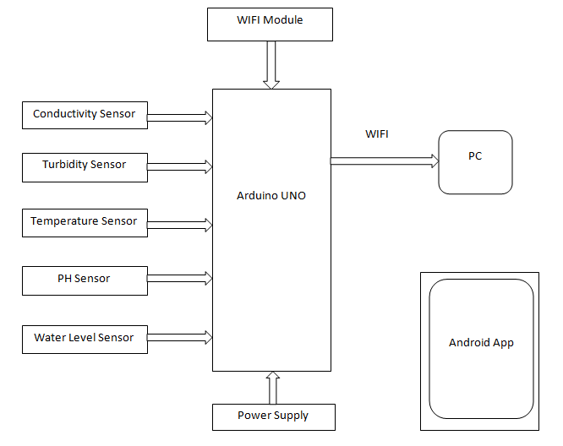
Fig1: Block diagram of the system using Wi-Fi module
The crucial parameters that are supervised by the system are conductivity, temperature, water level, pH and turbidity. Fig 1 illustrates the block diagram of the inclusive real time water quality monitoring system in IoT environs.
In this system, the sensors such as conductivity, temperature, water level, pH, turbidity sensor with a Wi-Fi module and a power supply is allied to the basic controller- Arduino UNO. The basic controller retrieves the sensor values which will be assessed by situating the sensors in distinct water samples and the data will be directed to the cloud by means of the WI-FI module. An android application recommended will be used to reveal the sensor values examined via cloud and warnings will be provided to user if the value outstrips the threshold value. The application can be used by users including water authorities which help them to check up the water state.
As the values will be passed to users in ordered interims, based on the scale defined for each parameter, users can have knowledge of about the water state. If the water is unhygienic then the related authorities can take measures needed to make the water clean and usable, even the society can take requisite measures in order to reduce the contaminants present in water. These measures can boost the water quality which makes it more usable.

TABLE II
COMPARISON BETWEEN DIFFERENT MODULES
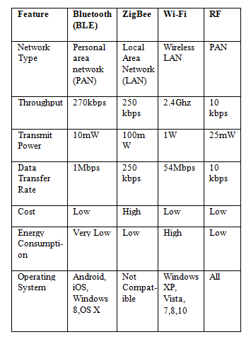
VI. CONCLUSION
The paper depicts a brief survey on the technology used in the existing smart water quality monitoring system and describes the technology used for this system. It also includes the international status of the system. Comparative study of the different mode of technologies used for real time monitoring. By employing this recommended system, the related authorities can take measures to boost the water quality which makes it more usable. These measures can diminish the contaminants present in water, which in turn cut off the threats caused due to usage of unclean water for daily life, assuring the acceptable facets of water.
REFERENCES
[1] Cho Zin Myint, Lenin Gopal and Yan Lin Aung,”Reconfigurable smart water quality monitoring system in IoT environment”, IEEE International Conference on Information Systems (ICIS), 978-1-5090-5507-4/17, May 2017. [2] A N Prasad, K A Mamun, F R Islam, H Haqva,”Smart water quality monitoring system”, IEEE International Conference on Computer Science and Engineering,10.1109,May 2016.
[3]Francesco A, Fliippo A, Carlo G C ,Anna M L,”A Smart sensor network for sea water quality monitoring, IEEE Sensors J 15(5):2514-2522,May 2015.
[4]S. P. Gorde, M. V. Jadhav “Assessment of Water Quality Parameters: A Review”, S. P. Gorde et al Int. Journal of Engineering Research and Applications ,ISSN : 2248-9622, Vol. 3, Issue 6, Nov-Dec 2013, pp.2029-2035.
[5]S. Geetha and S. Gouthami,” Internet of things enabled real time water quality monitoring system”, Springer open (2017) 2:1 DOI 10.1186/s40713-017-0005-y.
[6]Aaina Venkateshwaran, Harsha Mendha, Prof. Priti Badar,“An IoT based system for water quality monitoring”,International Journal of Innovation Research in Computer and Communication Engineering,Vol.5, Issue 4,April 2017.
[7] Vaishanvi V Daigavane, Dr. M A Gaikwad,”Water quality monitoring system based on IoT”, Advances in wireless and mobile communications, ISSN 0973-6972 Volume 10, Number 5, 2017, pp. 1107-1116.
[8] Aravinda S. Rao, Stephen Martial, Jayavardhana Gubbi, Marimuthu Palani Swami, “Design of low-cost autonomous water quality monitoring system”, 2013 IEEE, pp. 14-19.
[9] Cheng-Liang Lai, Chien-Lun Chiu “Using image processing technology for water quality monitoring system”, July2011 IEEE, pp. 1856-1861.
[10] Niel Andre Cleote, Reza Malekian and Lakshmi Nair,” Design of smart sensors for real-time water quality monitoring,”, vol 13, no. 9, September 2014 IEEE, pp. 1-16.

