**Casting Defect Analysis Using DMAIC**

**A.G.Thakare1, Dr.D.J.Tidke2**

*1Research Scholar,*

*G.H.Raisoni College of Engineering, Nagpur, India*

*2Ex. Professor*

*G.H.Raisoni College of Engineering, Nagpur, India*

***Abstract –*** *Casting is one of the most economical routes to produce metallic components in which the liquid metal is directly poured into the mould cavity of required size and shape. Formation of casting defects such as porosity, segregation, hot tears, etc. are some of the major drawbacks of casting processes. To improve the quality of their products many foundries implement. Six Sigma implementation has been globally popular in foundries. Implementation of Six Sigma programme benefits the foundries in numerous ways, one of the major benefit foundries get is the elimination of subjectivity in decision making. In this paper importance of Six Sigma methodology implementation in foundries along with the method has been discussed briefly.*

***Keywords-******DMAIC, Casting defects***

**INTRODUCTION**

One of the most important tasks caused by technological processes is the quick identification of quality issues. Traditional approaches quality and problem solving should be replaced with methods guaranteeing statistically significant solutions which results in cost reduction. Six Sigma methodology is one of the methods which is highly beneficial under such situations. Importance of this method has been proved by companies like Motorola, GE which successfully implemented this methodology since mid -80s.SixSigma is based on numbers, data and facts which allow to obtain an implemented and verified solution with a properly matched control standard. through its five consecutive stages Define, Measure, Analyse, Improve & Control (DMAIC) .Majority of errors committed during the realization of projects can be avoided using Six Sigma [1].

**II. DMAIC METHODOLOGY**

Organization can achieve strategic goal through effectively accomplishing projects. Satisfaction of customer requirements and support of business development through the elimination of defects and variability reduction, based on facts, data and statistical tools is the aim of DMAIC methodology. There should not be too many factors in project selection. As per literature review there should not be too many factors in project selection. Criteria which are most relevant to the process are sufficient. Five to eight variables relevant to criteria’s are enough. Six Sigma methodology can be implemented to casting process as discussed in the following sections [2].

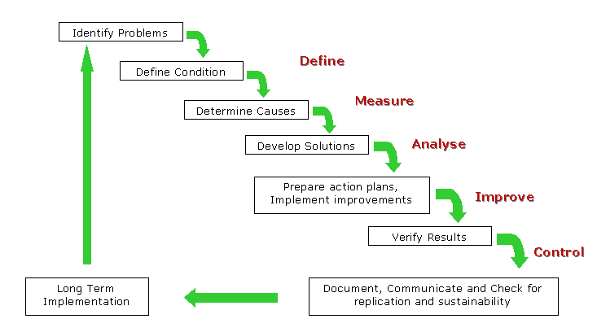

Fig.1: DMAIC Methodology

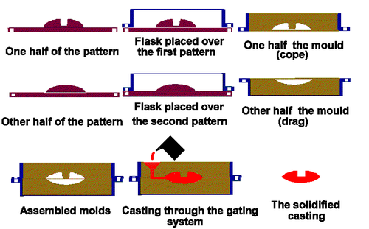

Fig.2: Process Map Casting Process

*A.* Define

Key issues and problems are defined and identified in the first phase of DMAIC.Casting defect is the most dissatisfaction area in the industry. Parameters which result in defects are identified for its effect on the Sigma performance of the process. Data is collected from the foundry floor and performance measures of the existing process are identified. Performance measures of the existing process are determined. In short goals of the improvement project in terms of customer requirements are identified and a process that delivers those requirements is developed. Voice of the customer is given priority by the project team members and customer language is translated into setting the goal [3].

 Fig.3: Six Sigma Basic Premise

B. Measure

Process parameters, that influence Critical to Quality (CTQ) are identified and measured in this stage. Understanding the process conditions and problems, collecting the data is done to pinpoint the location or source of problems. Tools which can be used in this

stage are

- Data Collection Plan, Data collection Forms

- Control Charts

- Pareto Charts

- Sampling

- Prioritization Matrix

- FMEA (Failure Mode and Effect Analysis)

[4].

 Fig.4: Critical to Quality (CTQ) Tree

C. Analysis

To identify the critical parameters having significant contribution in influencing the response functions valid relationship between process parameters and their corresponding response variables is identified.

In this context, Taguchi’s method of experimental design is a viable methodology, which not only provides the maximum amount of information with the minimum number of trials but also establishes functional relationships between the input and output variables . The idea is to identify the critical process parameters, increase system robustness, reduce experimental costs, and improve product quality. Root causes of the problem can be identified in this stage. Brainstorming, Cause-and-Effect Diagrams, Design of Experiments, Flow Diagram, Hypothesis Tests, and Regression Analysis can be effectively used in this stage. Team creates list of potential causes and to understand relationship between cause and effect organizes them. Basic assumption is data roughly fit a normal distribution. Causes are verified so that improvement focuses on the deep cause, not on the original symptom. Which causes are to be focused on in the improvement step are identified in this step.

D. Improve

Solutions targeted at the verified cause are developed, implemented and evaluated in this step. The goal is to demonstrate with data, that our solutions solve the problem and lead to improvement. Most commonly used are brainstorming, consensus, creativity techniques, data collection, design of experiments, flow diagrams, FMEA, hypothesis tests.

E. Control

In this final step it is ensured that problem is fixed on long term and new methods can be further improved over time. To ensure quality it is needed to

- verify the results and check if the changesintegrate to

all operating and compliance policies ofthe business

unit.

- document the new methods, so that workers find them

easy to use and train everyone who is involved into use

of the new methods.

- monitor the implementation and if needed make

corrections.

**III. CONCLUSION**

For identification of quality issues and reduction of process parameters based on data, numbers and facts DMAIC methodology with its statistical tools can be effectively used in foundry. It gives measurable financial profits in reducing the costs of poor quality and a number of non-financial benefits such as developing teamwork skills, improving project team members competencies, deepening the process knowledge together with the knowledge of root problem causes.If we do not measure, we do not know. If we do not know, we cannot act. I we do not act, we are running a risk of losses” M.J. Harry.

**REFERENCES**

[1] *G.Furgal et al., “Quality problems root cause identification And variability reduction in casting processes”, Archives Of Foundry Engineering, ISSN (1897-3310) Volume 9 Issue 1/2009 13-16* ***3/1.***

[2] *Sushil Kumar et al., “Six Sigma an Excellent Tool for Process Improvement – A Case Study , International Journal of Scientific & Engineering Research Volume 2, Issue 9, 2011..*

[3] *Suraj Patil et al., “Application of Six Sigma Method to Reduce*

*Defects in Green Sand Casting Process: A Case Study”,*

*IJRMEE, Vol.2, Issue 6, 2015*.

[4] *Bogdan Dumitru et al. , “Sigma Tools ForManagement Of Defects By Steel Casted Parts”, MACMESE'08*