Non-Newtonian Fluid Speed Breaker

Prof. Pooja J. Chauhan ¹,Satendrakumar Bopche², Ashwinee Kawale³, Rohit Sakhr³, Prafulsingh Chauhan⁵, Dnyaneshwari Chauragade⁶, Pranali Ramteke⁷,

¹ Asst. Professors, Dept. of Civil Engineering, M.I.E.T. SHAHAPUR, BHANDARA, INDIA 441906
^{2,3,4,5,6,7}B.E. Department of Civil Engineering, M.I.E.T. Shahapur, Bhandara, India

Abstract-In this reference paper new technology for road users is introduced. It is a technology used to reduce speeding up of vehicle, which includes at least non Newtonian fluid, fluid versatile material, stab proof material. The non Newtonian fluid is inserted in fluid versatile material and then to keep it safe from damages due to change in climate or temperature etc. When the vehicle traveling in high speed the viscosity of fluid is high due to sudden pressure and enables to deform quickly whether if the vehicle is in designed speed limit the viscosity is low and fluid get time to deform and hence no jerk is getting to vehicle. Hence the driver must slow down speed of vehicle to designed speed to avoid jerk.

Keywords—Speed Control, Shear Thickening,
Thixotropic Fluid, Liquid Breaker.
- INTRODUCTION
In this research paper we are going to introduce an advance, modified speed breaker i.e. Non Newtonian fluid speed breaker. In convectional speed breaker travelers getting impact whether they are in slow speed, but these non convectional speed breaker is giving reward to those who are driving slowly from breaker, as no bounce will feel to the travelers and speedy vehicles will feel the bounce or impact as high as the speed of vehicles. This paper relates to a traffic control device sensitive to the speed of a vehicle. The “Non Newtonian fluid speed breaker” aims to overcome all these short comings of the conventional speed control devices. The ideal situation is that if the vehicle travels at a very low speed, the stiffness of the obstacle reduces to facilitate the vehicles passage without any bounce or jump. However if the vehicle exceeds the advisable minimum speed the obstacle stiffness increases and the vehicle encounters a considerable jump. This speed control device will also allow emergency vehicles to traverse speed breakers without having to reduce their speed which in turn will reduce their response time to emergencies. Hence instead of modifying vehicles, modification of speed breakers can also be done to prevent vehicles from getting impact.

II. PROBLEMS WITH CONVENTIONAL SPEED BREAKERS

Speed breakers are provided to reduce the speed of vehicles but heavily loaded vehicles can pass speedily through it without getting impact. Hence purpose of speed breaker to reduce the speed of vehicles is not to be
Conventional devices are known to help slow down the
Speed of traffic in selected areas. For example, conventional speed breakers or rumble strips are used in such places as school zones, parking lots, construction zones, hospital zones and similar areas where it is desired to control or reduce the speed of vehicles for the safety of pedestrians. A conventional speed breaker usually consists of a concrete or asphalt breaker formed in the road. Drivers must slow down when driving over these speed breakers to prevent damage to their vehicle. However, even if travelling at the posted speed limit or below, these conventional speed breakers can take a toll on a vehicle’s mechanical components. The conventional speed breakers are very heavy and, once in place, are typically permanent fixtures on the roadway. In order to remove a conventional speed breaker, the speed breaker must be broken up and the roadway repaired where the speed breaker used to be. Another major problem associated with such speed breakers is that they often cause spinal damage or aggravate chronic backache due to the constant shocks suffered while traversing the speed breakers. Additional criticism of speed breakers includes their effect on emergency vehicles. Response time is slowed by 3–5seconds per breaker for fire trucks and fire engines and up to10 seconds for ambulances with patients on board. Also there is an increase in traffic noise from braking and acceleration of vehicles on streets with speed breakers, particularly from buses and trucks. They end up increasing noise levels where they are implemented. Therefore, it would be advantageous to provide a traffic control device that reduces or eliminates at least some of the problems associated with conventional speed breakers. The “Non Newtonian Fluid Speed Breaker” aims to overcome all these short comings of the conventional speed control devices mainly reduces jerk to vehicle and increase its life span.

III. LITERATURE REVIEW

1) Catherine Berthod, Engineer and Urban Planner Minister Des Transports du Québec Annual Conference of the Transportation Association of Canadian Edmonton, Alberta
To respond to this need, the ministered des Transports du Québec has begun publishing a series of fact sheets on a variety of traffic calming measures including: speed humps and speed cushions, raised crosswalks and intersections, neck downs (curb extensions at intersections),the reduction of the width of streets, centre islands and chicanes. A general fact sheet presents all of the measures and notably outlines the procedure for pre implementation analysis. The presentation will present the first two published fact sheets: the general fact sheet and the factsheet on speed breakers and speed cushions. Speed control is a key factor in road safety. It is for this reason that the ministered hopes to support municipal initiatives related to the use of traffic calming measures. By issuing these fact sheets, stakeholders will have easy access to pertinent information as well as concrete examples to help them design the solution best suited to every situation.

IV. MATERIALS

A. Polyethylene Glycol
Polyethylene glycol (PEG) is a polymer derived from ethylene oxide is an advantageous component for obtaining solid dispersions due to their physicochemical properties. It has hydroxyl groups (OH) as electron donors that are responsible for the interaction with hydrophobic compounds through hydrogen bonds; they are also responsible for biocompatibility; odorless characteristics; neutrality; nonirritating; and solubility in many organic solvents and in water, providing a quick release of the dispersed drug, and facilitating the process of obtaining by the solvent method PEG has a low melting point, rapid solidification rate, ability to form solid solutions, low cost and low toxicity and is therefore mainly used as vehicle for the preparation of dispersions

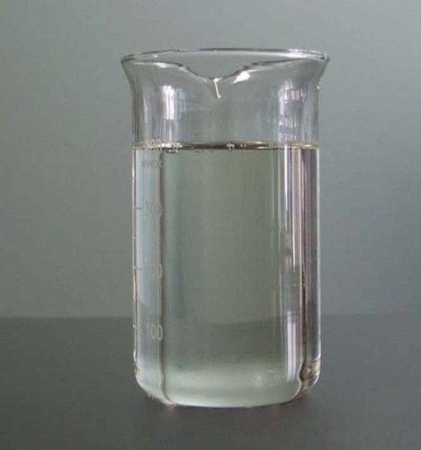
Fig: Polyethylene Glycol

B. Silica Dioxide
SiO₂Nanoparticles, also known as silica Nan particles or Nano silica, are used due to their stability, low toxicity and ability to be functionalized with a range of molecules and polymers. Nano-silica particles are divided into P-type and S-type according to their structure. The P-type particles are characterized by numerous Nan pores having a pore rate of 0.61 ml/g.
Chemical Formula SiO₂
Appearance Amorphous Powder
Molar Mass 60.08 g/mol
Density 2.196 g/cm³

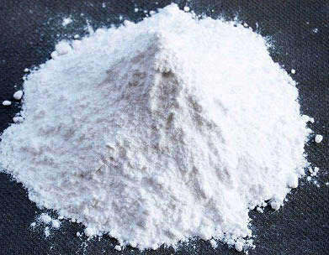
Fig: Silica Nano Powder

Corn Starch

Corn starch or maize starch is the starch derived from the corn (maize) grain. The starch is obtained from the endosperm of the kernel.

Chemical Formula C₂₇H₄₈O₂₀
Appearance Amorphous White Powder
Molecular Weight 692.661g/mol
Density 1.5 g/cm³

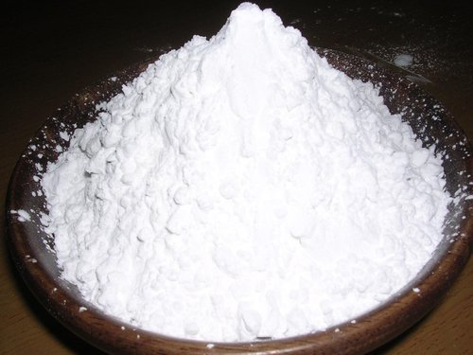
Fig: Corn Starch

D. Reinforced Rubber Layer Pipe

The hose lining is rubber, which is reinforced with multiple layers of spirally applied high tensile steel or fabric reinforcing cords, to provide pressure and external load resistance. At least one helical steel wire is then applied outside of the main reinforcement and this wire is totally embedded within a rubber matrix. The hose carcass is completed with further fabric reinforcement and a rubber cover.

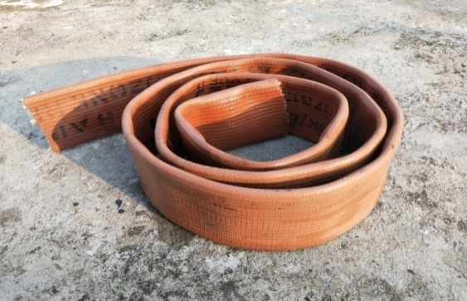
Fig: RRL Pipe

E. Carbon Rubber Matting

Recycled rubber used in this breaker. The thickness of rubber matting is 3 mm.

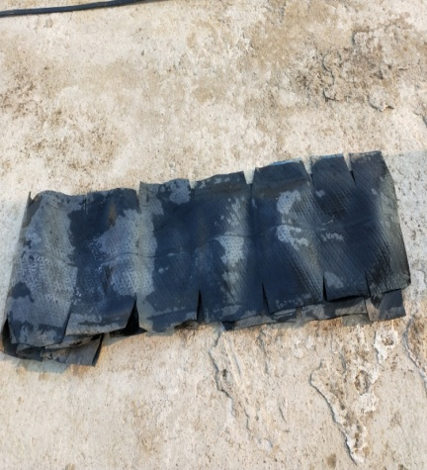
Fig: Rubber Matting

V. DESIGN AND IMPLEMENTATION

The non Newtonian fluid speed breaker is consisting of stab proof material, reinforced rubber layer, non Newtonian fluid, and highlighter, hold fast and fasteners.
The non Newtonian fluid i.e. polymer gel, is packed in reinforced rubber layer which is covered from both sides which is air tight stopper and fixed carefully to avoid drip. The reinforced rubber layer is hold with hold fast at both ends to get better grip between RRL and concrete or asphalt. Then the layer of air tight synthetic rubber is laminated to prevent the RRL and polymer gel from penetration of air. The air tight synthetic rubber is inadequate to assist the stab or smash and hence the Nylon fabric is used to cover up from aches. The breaker can be either permanently or temporarily placed to a roadway with bolts, screws. The cover can be formed of reinforced rubber material. The cover encloses with Non Newtonian fluid, which reversibly hardens or stiffens in response to an applied pressure and goes back to its original form when the pressure is relieved. To provide grip to hole set up with road, metal sheet is placed on both sides of the speed breaker with number of apertures. The complete setup arranged over road and metal sheet is planned over it and adhere with the help of the fasteners or bolts. Also to avoid accidents due to unawareness of speed breaker, layer of radium is laid down which will reflect the light of vehicles and driver gets aware about the speed breaker. The housings are in the form of elongated, hollow, flexible tubes having closed ends. The tubes are made up of either polymeric or rubber material. The flexible tubes are filled with a non- Newtonian fluid .If the vehicle travels at a low speed, fluid is moved and breaker is deformed, depression of the strip occurs in the area in which the wheels pass over, forming a small obstacle to the passage of the vehicle. However, if the speed of the vehicle is high then the fluid has no time to displace and a considerably smaller depression occurs. Hence the strip forms a step with greater height, causing the vehicle to jump, warning the driver about his excess speed. The fluids used to fill the housings are non-Newtonian fluids. A non-Newtonian fluid is a fluid the viscosity of which varies with the pressure gradient applied. As a result, a non- Newtonian fluid does not have a defined and constant viscosity value, like a Newtonian fluid. The Non Newtonian fluid acts like a fluid below a critical shear rate but above the critical shear rate, the material acts like a solid.
The non-Newtonian fluid acts as controlling the resistance by the strip to its deformation. It depends on the speed of the wheels of the vehicle on it. Thus, if the vehicle travels at a low speed the fluid has a low viscosity and the strip is easily deformed, whereas if the speed of the vehicle is high the viscosity of the fluid is high and as a result has great resistance to deformation, thus forming a rigid obstacle to the passage of the vehicle.

IX. FUTURE SCOPE

- Economical.
- Suitable at parking of multiplexes, malls, toll booths, signals etc.
- Liquid speed breaker used in France and Germany.
- Reduce air and noise pollution.
- Increase fuel efficiency in some extent.
- Low maintenance cost.
- Response time of emergency vehicle not affected.

VI. REFERENCES

- L. R. Kadiyali, Traffic Engineering and Transport Planning, 2015, pp 456.
- Rahul Bagchi, “Traffic calming measures”, International Journal of Chemical, Environment and Biological Sciences (IJCEBS), Volume 1, 2013.
- IRC: 99 – 1988, “Tentative Guidelines On The Provision Of Speed Breakers For Control Of Vehicular Speeds On Minor Roads”,
- Roger W. Louson, “The Objections to Speed Humps”, Published by the Bromley Borough Roads Action Group, October 2003.
- K. Subramanya , Tata McGraw-Hill Education ,Hydraulic Machines
- ITE. "Traffic Calming Measures – Speed Hump”. Institute of Transportation Engineers.
- Sahoo P. K., "Geometric Design of Speed Control Breakers, “International Journal of Advanced Technology, 2009.
- Ponnaluri Raj V, And Groce Paul W., “Operational Effectiveness of Speed Bumps in Traffic Calming,” It Journal, July 2005.

