Size Based Sorting of Metal/Non-metal Objects using PLC: A Review

Piyush K. Bhirud¹, Pooja R. Chaudhari², Ujjwala A. Joshi³, I. S. Jadhav⁴, Vijay D. Chaudhari⁵
^{1,2,3} B.E. Students, ^{4,5} Asstt. Prof.
^{1,2,3,4,5} E&TC Engg dept., GF’s Godavari College of Engineering, Jalgaon-425003, Maharashtra, India.
piyushbhirud1997@gmail.com ¹, ishwar.jadhav@rediffmail.com ⁴, vinuda.chaudhari@gmail.com⁵

Abstract
Low-Cost Automation (LCA) sorting system are simple and can be changed as per the requirement. In industrial technology automation is highly required. The proposed system will be automation sorting and will have future application. The proposed system will be combination of two different sorting system by making four different logic mainly focusing on developing automation having low cost.

Keywords – Low-Cost Automation (LCA), combination sorting, PLC, ladder diagram

1. INTRODUCTION

In this paper we have mentioned a low cost automation system for sorting object on the basis of metal & non metal and also identifies the size of object (small & large only). The goal of our paper is to combine two different sorting systems. So that it would reduce the cost of two Existing machine and it can be affordable for low scale industries which will be the Low cost Automation (LCA). The existing system is of metal and non-metal sorting and another is small and large object sorting.

2. LITERATURE SURVEY
In previous paper the author has worked to detect the type of material (wood, plastic, metal) and also identifies size of material (small, medium large). The system is sort the material separately in assign basket by using pneumatic cylinder (controlled by PLC). The system is proposed to solved the problem is MMS (material management system). This system is for multi-sorting of three different object in three different size of material by using PLC & proximity sensor. The identification of material with minimum time interval is 0.5 sec between testing object [3] The use of proximity sensor is more costly than IR sensor. The author has worked on identifying the object on the basis of weight, colour, and type of object (metal or non metal). The system is proposed to solve the problem is low cost automation system. The object is sort by weight & colour only [1]. The author has worked on the metal separation & packaging only. To solve this problem the author has used a PLC based system sequence of separation is being designed by ladder diagram. In this paper the author has made fully automatic metal separation & its packaging successfully [2]. In our paper we are worked to detect the type of material (metal & non-metal) and also identifies the size of object (small and large only).
2.1 Problem Statement
The rapid growth in automation industries leads us to mechanize, innovate and research about the automation and overcome the problem. Within the survey & the problem identified was the cost for the sorting machine. Another problem was the different machine for different sorting likewise the two different machines are for size box sorting & another for metal and non metal sorting.
Within the survey many system like colour, plastic, wood, metal sorting can be seen. Some of the systems were based on microcontroller where PLC is more flexible then the Microcontroller.
To overcome this problem we have found that PLC is a easy & effective way to design for a wide variety of automatic task with feeding it with a simple ladder logic for entire control systems.
By accuracy & precision PLC overcome the problem as per the input & output required for the project. PLC is selected of 8 input & 6 output where cost get reduced.
Building a sorting machine for small scale industries should be affordable. So by combining the metal & non metal sorting machine with size based object sorting machine. The costs of two different machines get reduced nearly half away by combining then both with an easy logic which is operated on a single plc. As a single conveyer can carry metal & non metal, small & large object sending them to different section.
The cost is relatively changed with modification in the system & improving size of conveyer & adding sensor.
2.2 Proposed Method/System
In the time of speedy running technology the automation is gone to a higher level development. In this project the system is proposed to solve the problem is LCA (low cost automation). The working of this project is easy to explain and less costly. This project is developed for sorting of metal and non metal object with size like small and large size. Where logic is controlled by PLC (programmable logic controller).
3. METHODOLOGY
3.1System Hardware
Here the conveyer is used to pass the object in front of sensor which is drive by DC motor.
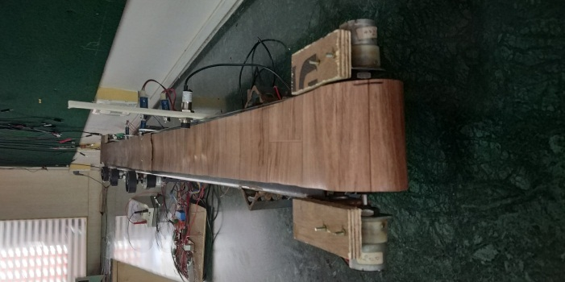
Fig 1- Conveyor belt and assembly
The metal sensor is inductive sensor which senses the object in 0.5 sec. As this object has the sensing at variation in size the IR sensor are used for the sensing of object by mounting the sensor on the particular height. The high level sensor senses the big object and vice versa.
For sensing at the object motor are used to push the object from the conveyer to the sorting bin. The other part at IR sensor are mounted on the conveyer for sensing of object that has reached its rightful place for sorting and the motor push the object from the conveyer to sorting bin.
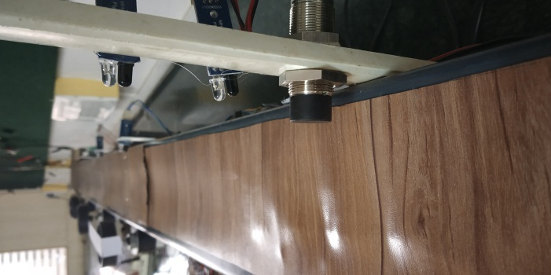
Fig 2- Metal sensor With small and large sensor
The whole system is calibrated by PLC with the logic feeded in it. The logic is developed for sorting of four condition
- Small metal object
- Large metal object
- Small non metal object
- Large non metal object
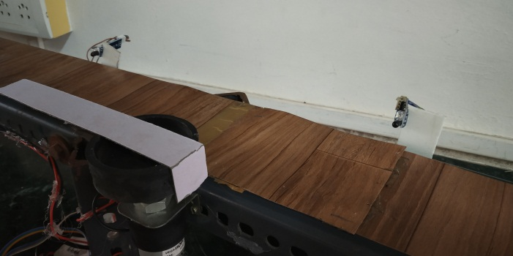
Fig 3- Sorting assembly with sensor and motor

3.2 System Software
The selection of software is as the PLC used is of Delta. So the software that was available for program PLC & simulation is WPL software with suitable cord and drive used.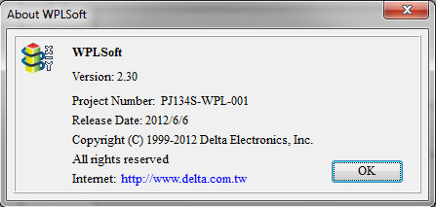
WPL soft is of version 2.30. If the company of PLC is changed than the software required to program the PLC should be the same company which PLC is. So that the software and the PLC should interact with each other. With suitable cord and drivers.
4. DISCUSSION
1) As our proposed system in PLC bored. The PLC is very flexible to use & can easily reprogrammed. So more implementation can be done in the system by adding extension module to plc.
2) The system can be modified with combination of colour sorting.
3) System consists of mechanical part, so many more worked can be done in it.
4) Sorting load can carry out by Hydraulic, Pneumatic system. For effective sorting as per the scale of industry & cost will be more.
5) PLC can be attached with the extension module of input & output so it has grate approach in improving and accurate sorting.

5. CONCLUSION
After making the literature survey & observing that the low cost automation is found in technical & industrial field and is very essential, so we have design the sorting machine which will put the light on application of combination sorting & low cost automation (LCA).

REFERENCES
[1] Sorting of Objects Based on Colour, Weight and Type on A Conveyor Line Using PLC S. V. Rautu, A. P. Shinde, N. R. Darda,A. V.Vaghule, C. B.Meshram, S.S.Sarawade (Department of Mechanical Engineering, M.E.S. College of Engineering, Pune, S.P. Pune University, India)
[2]Automatic Metal Separation and Packaging Using PLC TP.Thirumurugan Assistant Professor Department of Instrumentation and Control Engineering, Saranathan College of Engineering, Tiruchirappalli-620012. TUthirum.tech16@gmail.comU31T
[3] PLC Based Automated Object Sorting System
Rakhshan Zulfiqar, Bushra Mehdi, Rumaisa Iftikhar, Tahmina Khan, Razia Zia, Najam Saud Sir Syed University of Engineering & Technology, Karachi, Pakistan.

