Detailed study of Routing Protocols in MANETs
Sakshi Kaple¹, Saurabh Somkuwar²
¹Student,
Government College of Engineering, Nagpur, India, 441108
²Student,
Government College of Engineering, Nagpur, India, 441108

Abstract – Mobile Ad Hoc Networks (MANETs) are self-configuring and self-organizing multihop wireless networks. They are infrastructure-less networks of mobile devices allowing dynamic changes in structure. Standard Wi-Fi connection and mobile hotspots are examples of MANETs. They are typically not very secure and one needs to be cautious about the type of data being sent.
They consist of a peer-to-peer, self-forming, self-healing network. The components of MANETs lack a physical connection and hence can move independent of each other in any direction giving rise to a highly dynamic, autonomous topology.
A routing protocol ensures the proper working of functionalities such as mobility of nodes, multipath propagation, interference and path loss in the constantly changing topology of MANETs. Major routing protocols that have been developed are Proactive Protocol, Reactive Protocol and Hybrid protocol.
The distinction of these protocols is primarily based on parameters such as routing approaches, structure, selection route, routing table, maintenance, operation of protocols, strengths and weaknesses. The method of determining routes within source-destination pairs decides the uniqueness as well as efficiency of these protocols..
Keywords- MANET, Routing protocols, DSDV, AOD..
INTRODUCTION
A Mobile Ad Hoc Network (MANET) is a collection of wireless nodes forming a temporary, infrastructure-less network. MANETs do not require a fixed topology and rely on wireless terminals for routing and transport services. MANETs are characterized as peer-to-peer, self-forming, self-healing networks without any physical connections. The structure of the network changes dynamically and due to this mobility of the nodes, MANETs are self-organizing and self-configuring. They may contain one or more different trans-receivers between the nodes resulting in a highly dynamic, autonomous topology. Each node in a MANET sends to as well as receives data from other nodes thereby acting as a router. Each router forwards traffic unrelated to its own data. Each device or node in a MANET must continuously maintain information required to properly route traffic. MANETs are mostly employed in Battlefields, Disaster areas and meetings because of their ability to handle node failures and fast topology changes. MANETs allow seamless communication between devices or people in even in the absence of a proper communication architecture. In MANETs, routing protocols are required to establish specific paths between the source and the destination. The primary aim of a routing protocol is to establish an efficient route between any two nodes with minimum routing overhead and bandwidth consumption. Factors such as interference, mobility of nodes, multipath propagation and path loss continuously change the topology of MANETs for which a dynamic routing protocol is required. There are three major categories of MANET routing protocols: Proactive Protocol, Reactive Protocol and Hybrid Protocol.
The paper focusses on MANET protocols, its types and the examples in each category. It discusses DSDV and AODV protocols in detail. The section ahead of it provides comparative study of various protocols.
METHOLOGY
A MANET routing protocol must necessarily perform the following three functions:
- Keep the routing table up-to-date and reasonably small.
- Select the best route for given destination.
- Converge within an exchange of a small amount of messages.
As mentioned, the three categories of MANET routing protocols are Proactive, Reactive and Hybrid. These protocols are designed to handle a number of nodes with limited resources.

- Proactive Routing Protocols: Proactive routing protocols use link-state routing algorithms to link information about neighbours. This information is stored in the routing tables maintained at each node. The maintenance and updating of information is done by exchanging the control packets with their neighbours.
Proactive protocols are table-driven with high routing overhead. They maintain a low latency rate due to routing tables. Proactive routing protocols function on low scalability yet the routing information is always available. They receive periodic updates whenever the topology of the network changes and their mobility is highly dependent on these updates.
Examples of Proactive routing protocols are: DSDV, OLSR, CGSR, WRP, TBRPF and QDRP.
The Destination Sequenced Distance Vector (DSDV) protocol is highly used across all applications of MANETs. It provides independence from loops in routing tables and is much dynamic in nature. In DSDV, each node maintains a routing table containing the destination node address, the minimum number of hops to that destination and the next hop in the direction of that destination. Say a given node receives two updates from the same source node, then the receiving node decides as to which update is to be placed in its routing table based on the sequence number. A higher sequence number denotes a more recent update sent by the source node. Therefore, it can update its routing table with the latest information and avoid any route loops or false routes.

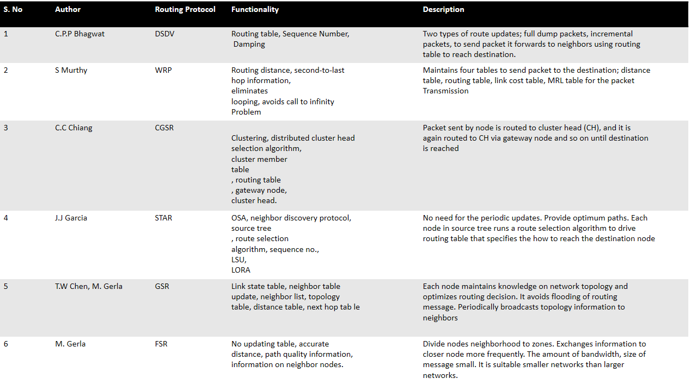
Table: Comparison of various Proactive Protocols
- Reactive Routing Protocols: Reactive routing protocols reduce the overhead on Proactive protocols and use the distance-vector routing algorithms. They help in finding a route to the destination on-demand. This on-demand route acquisition is based on request made by a node for the initiation of route discovery process. The routing overhead in reactive protocols is low due but they have high latency due to flooding. These protocols are not suitable for large networks and they make routing information available only when required. They do not require any periodic updates and they achieve mobility through route maintenance. Examples of Reactive routing protocols are AODV, LMR, TORA, DSR and LQSR. The Ad hoc On-Demand Distance vector (AODV) Protocol is the most highly used Reactive protocol. It performs Route Discovery using Control messages Route Request (RREQ) and Route Reply (RREP). The forward path sets up an intermediate node in its route table with a permanent association to RREP. When either destination or intermediate node using moves. A route error (RERR) is generated and sent to the affected source node every time when one among this intermediate node or the destination moves. Upon receiving the error, the source node can reinitiate the route and the required neighbourhood information is obtained from broadcast Hello packet. AODV protocol is a flat routing protocol and does not need any central administrative system to handle the routing process. It tends to reduce the control traffic messages overhead at the cost of increased latency in finding new routes. The AODV has great advantage in having less overhead over simple protocols which need to keep the entire route from the source host to the destination host in their messages. The RREQ and RREP messages do not increase the overhead from these control messages. AODV reacts relatively quickly to the topological changes in the network and updates only the hosts that may be affected by the change, using the RRER message. The Hello messages are also limited so that they do not create unnecessary overhead in the network. The AODV protocol uses sequence numbers and thus, is loop free. It avoids counting to infinity problem, which was a characteristic of the classical distance vector routing protocols.
- Hybrid Routing Protocols: Hybrid routing protocols are a combination of both Proactive and reactive protocols designed with a scalability suitable for large networks. The route acquisition in Hybrid Protocols is again a combination of on-demand and table driven methods. It has a medium routing overhead with a latency similar to that of reactive protocols on the outside. It is open to receiving periodic updates and handles routing information depending on the situation. If available, the information is supplied or else it is generated according to the demand. Examples of Hybrid Routing Protocols are: ZRP, BGP and AIGRP.
Comparison between routing protocols:

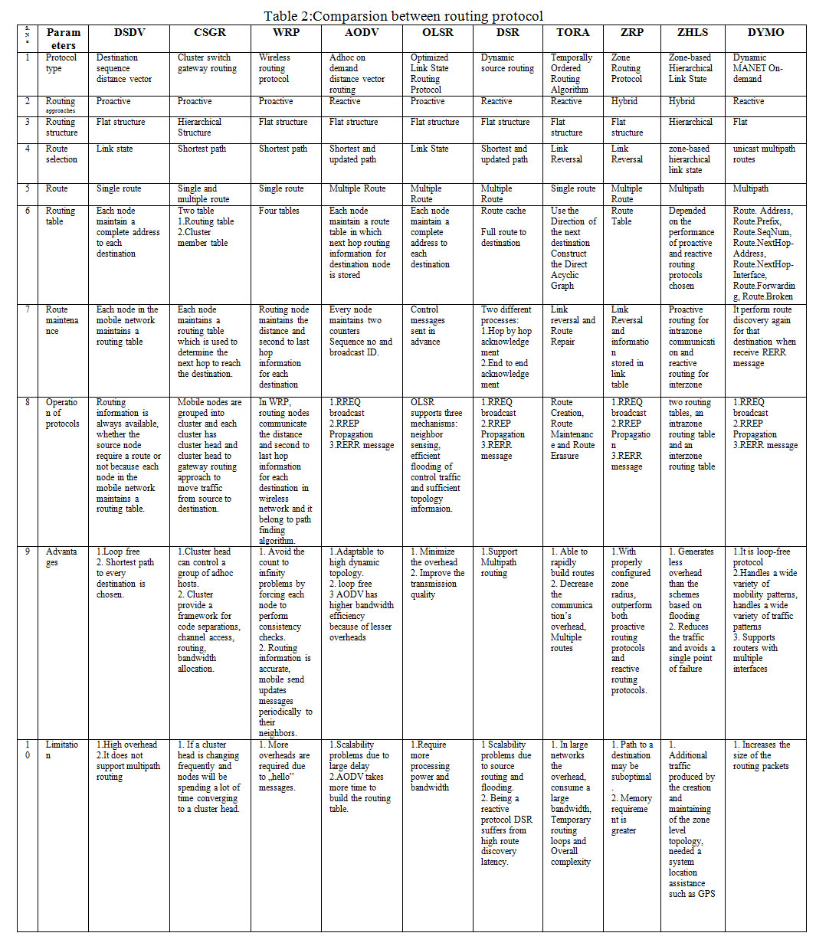

CONCLUSION
This paper provides a study of Routing Protocols in Mobile Ad Hoc Networks. They are classified as Proactive or table-driven, Reactive or on-demand and Hybrid. The main factor that distinguishes these protocols is the method of determining routes within the source-destination pairs. DSDV in Proactive and AODV in reactive are the two main protocols used.

REFERENCES
- Venkatesan, T Prasanna & Rajakumar, P & Pitchaikkannu, A. (2014). Overview of Proactive Routing Protocols in MANET. 173-177. 10.1109/CSNT.2014.42.
- Sagar R. Deshmukh, P. N. Chatur, "Secure routing to avoid black hole affected routes in MANET", Colossal Data Analysis and Networking (CDAN) Symposium on, pp. 1-4, 2016.
- C. Mafirabadza, P. Khatri, "Energy analysis of AODV routing protocol in MANET", Communication and Signal Processing (ICCSP) 2016 International Conference on, pp. 1125-1129, 2016.
- Sagar R Deshmukh, P N Chatur, Nikhil B Bhople, "AODV-based secure routing against blackhole attack in MANET", Recent Trends in Electronics Information & Communication Technology (RTEICT) IEEE International Conference on, pp. 1960-1964, 2016.
- Eduardo El Akkari Sallum, Guilherme dos Santos, Mario Alves, Max Mauro Santos, "Performance analysis and comparison of the DSDV AODV and OLSR routing protocols under VANETs", Intelligent Transportation Systems Telecommunications (ITST) 2018 16th International Conference on, pp. 1-7, 2018
- Yuxia Bai, Yefa Mai, Nan Wang, "Performance comparison and evaluation of the proactive and reactive routing protocols for MANETs", Wireless Telecommunications Symposium (WTS) 2017, pp. 1-5, 2017
- Shaveta, Pawan Luthra, Er. Gagandeep, "Implementation of blackhole attack under aodv routing protocol", Energy Communication Data Analytics and Soft Computing (ICECDS) 2017 International Conference on, pp. 575-579, 2017
- Dimitra G. Kampitaki, Anastasios A. Economides, "Exploiting Selfishness Altruism and Common Welfare to Enhance Performance of Routing Protocols for Mobile Ad hoc Networks", Wireless Personal Communications, 2018.
- Lalar S, Yadav A.K. Comparative Study of Routing Protocols in MANET. Orient J Comp. Sci. and Technol; 10(1)

