Devanagari Script based Fancy Vehicle Number Plate Recognition using Machine Learning Approach: A Survey

Dr. Omkar S. Vaidya¹, Rishant Patil², Kirtee Narkhede³, Rushabh Karnavat⁴
¹Associate Professor
#Sandip Institute of Technology and Research Centre, Nashik, India, 422213
^{2, 3, 4} UG student
#Sandip Institute of Technology and Research Centre, Nashik, India, 422213
#Affiliated to Savitribai Phule Pune University, Pune
Email of Corresponding Author: omcar.vaidya@gmail.com

Received on: xxxx,20xx, Revised on: xxxx,20xx, Published on: xxxx,20xx

Abstract –It is important to ensure that all vehicles have a standard number plate as required by law to ensure proper identification and safety on the roads. The vehicle number plate recognition systems are a useful tool for improving security, traffic management, and overall efficiency in various industries. Currently, many techniques have been developed to detect vehicle number plate and recognize the characters but work related to fancy number plate detection specifically in Devanagari script is untouched yet. This paper surveyed various methods to detect and recognize the vehicle number plate depending on specified applications. We implemented the system using embedded devices and developed the number plate localization method. Finally, we proposed the machine learning approach to recognize the character from fancy number plate.
Keywords- Character Segmentation, Global System for Mobile Communications, ESP Module, Fancy Number Plate Recognition, Machine Learning, Regional Transport Office.
- INTRODUCTION
NNumber plate recognition systems are becoming increasingly popular due to their various benefits, some of them are like Enhance security, Traffic management, Parking management, Toll collection, Law enforcement etc. [1]. This system used to enhance security by identifying suspicious or stolen vehicles, aiding in investigations, and preventing vehicle theft. Also, it is used to monitor traffic flow, identify vehicles that violate traffic rules, and generate traffic reports. This can help traffic authorities to better manage and control traffic on roads. Further, it is used to manage parking spaces in public places, such as airports, shopping malls, and hospitals. The system can be used to identify vehicles that have overstayed their parking time, and issue fines or penalties accordingly. It helped to collect tolls on highways and bridges. The system can identify vehicles passing through toll gates, and automatically deduct the toll amount from the driver's account. The foremost significant role is to identify vehicles that have been involved in criminal activities, such as robberies, kidnappings, or hit-and-run accidents. The system can help the police to quickly locate and apprehend suspects [2].
All motor vehicles must have a standardized number plate in India, which must include the state code, the vehicle type emblem, and a special registration number. To make it simpler to identify automobiles and increase road safety, such vehicle number plates were standardized [3]. However, there may be cases where vehicles do not have a standard number plate, such as illegal vehicles or those with fake plates. It is difficult to estimate the number of such vehicles in India, as they are not registered with the authorities and often go unnoticed.
According to a report by the Ministry of Road Transport and Highways, as of 2019, there were over 25 crore registered vehicles in India [4]. The report also noted that there were over 30 lakh cases of traffic violations related to number plates, such as improper display or use of unauthorized plates, in 2018. Some sample fancy number plate in Devanagari script is shown in Fig. 1.
Automatic number plate recognition (ANPR) system is a technology that uses optical character recognition (OCR) software and cameras to read and recognize license plate numbers on vehicles. The ANPR system works by capturing an image of a vehicle's license plate using a camera, and then using OCR software to extract the characters from the image [5].
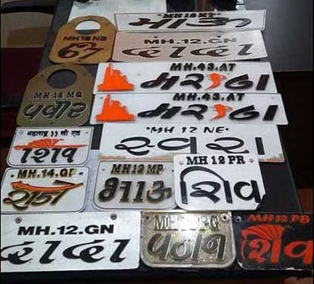
Fig. 1- Sample Fancy Vehicle Number Plate
The extracted characters are then compared to a database of known license plate numbers to check for matches, or processed to generate information such as the location, time, and date of the vehicle's presence.
ANPR technology has many advantages over manual methods of license plate recognition, such as increased accuracy and speed, and the ability to process large volumes of data in real-time. However, it also raises concerns about privacy and civil liberties, as it involves the automated collection and processing of personal information.
In this paper, we proposed Fancy number plate recognition, also known as vanity number plate recognition, which uses computer vision and machine learning techniques to detect and recognize vehicle number plates that have been designed with unique fonts, colors, or styles in Devanagari script. This script is most widely adopted over 120 different languages which comprised mainly Marathi, Sanskrit, Hindi etc. The main contribution of our paper is to develop a model to detect the feature which is combination of letters and numbers in Devanagari fonts which is complex script with many ligatures and variations, making it difficult to accurately recognize characters. This involves training a model on a large dataset of images of Devanagari number plates, and then using the model to recognize characters in new images. Once the number plate is recognized then if driver violate traffic rules, such details will be sent to nearest Regional Transport Office through GSM module.
The outline of the paper is as follows: Section II describe various technique to detect vehicle number plate followed by real time applications implemented by different researchers in Section III. Section IV explained the proposed methodology to detect fancy vehicle number plate using different Machine Learning algorithms. The design of power supply and PCB design work is presented in Section V. Finally, the paper is concluded in Section VI.
- VEHICLE NUMBER PLATE DETECTION TECHNIQUE
There are several algorithms that can be used to detect vehicle number plates, but one of the most commonly used techniques is called the "Haar Cascade Classifier". This algorithm is a variant of the Viola-Jones object detection framework, which uses a machine learning approach to detect objects in images [6]. The Haar Cascade Classifier works by training a model on a large dataset of images that contain both positive and negative examples of the object being detected, in this case, vehicle number plates. The positive examples would be images of vehicles with clearly visible number plates, while the negative examples would be images of vehicles without number plates or with obscured number plates. Once the model has been trained, it can be used to detect number plates in new images by analyzing the patterns of light and dark regions in the image. The algorithm looks for specific features that are characteristic of number plates, such as the rectangular shape, the presence of characters and the contrast between the characters and the background.
Another important technology is optical character recognition (OCR) which uses algorithms to convert scanned images of text into machine-readable characters. To extract alphabets and numbers from a vehicle number plate, an image of the plate is captured by a camera, which is then processed using OCR software [7]. The algorithm identifies the characters on the plate by analyzing the patterns and shapes of the characters.
Furthermore, there are two main types of machine learning algorithms that can be used to detect vehicle number plates: supervised learning and unsupervised learning [8], [9]. A labelled dataset is necessary for supervised learning algorithms, which means that the system must be trained on instances that have already been assigned the right output. This means that in the case of vehicle number plate detection, the algorithm would be trained using pictures of automobiles with correctly classified number plates. Convolutional Neural Networks (CNNs), Support Vector Machines (SVMs), and Random Forests are well-liked supervised learning methods for image detection [10]. Unsupervised learning algorithms attempt to find patterns and structures in the input data on their own and do not require labeled data [11]. The algorithm would examine photos of automobiles to find recurring patterns or features that suggest the existence of a number plate in the instance of vehicle number plate detection. Principal Component Analysis (PCA), Autoencoders, and k-Means clustering are popular unsupervised learning algorithms for image detection [12].
In general, supervised technique is the more common approach and tends to be more accurate, but requires a large amount of labeled data for training. Unsupervised technique can be useful in certain situations, but typically requires more fine-tuning and manual intervention to achieve optimal performance.
- RELATED WORK
Luo et al. [13] have relied on edge-based techniques for vehicle number plate detection because every number plate is rectangular and has a known aspect ratio. However, relying just on the horizontal lines can produce inaccurate results because vehicle front bumper may be selected as horizontal edge. A novel technique by Duan et al. [14] that combines the Hough transformation with a contouring algorithm produced faster results but was extremely sensitive to undesirable edges and was unsuitable for usage with complicated or fuzzy images.
A binary image is subjected to a wavelet transform using the Haar-scaling function in [15]. The LH sub-band is then used to locate a reference line with the greatest horizontal variance. The candidate regions are then extracted using the reference line, and ultimately, the extracted candidates are used to precisely find the vehicle number plate. This technique required complicated computations, and performed poorly against complex backgrounds and under various lighting situations.
Jithmi Shashirangana et.al [16] surveyed two categories for number plate recognition viz. multi-stage and single-stage recognition. For a variety of datasets, the single-stage deep learning-based systems have demonstrated strong performances. Large datasets can be used to pre-train multi-stage object detection based deep learning systems, although they have demonstrated lower computing efficiency and accuracy than single-stage approaches.
Authors in [17] proposed various deep learning techniques viz. AlexNet or R-CNNL3 prior to localize the vehicle number plate using YOLOv4 (You Only Look Once) model, but its real-time implementation necessitates a powerful GPU. Irina Pustokhina et.al described optimal K-means (OKM) clustering-based segmentation and CNN based recognition to detect the number plate and achieved 98.1% overall accuracy on Stanford Cars, FZU Cars and HumAIn 2019 Challenge dataset.
Sushant Poojary et.al [11] presented a survey of various deep learning methods to detect the vehicle number plate viz. Single Shot Detector (SSD), R-CNN and its variants, BlitzNet and YOLO based on their average percentage accuracy. Also, various character recognition algorithms are reviewed Template Matching, Artificial Neural Network (ANN), Deep Neural Network (DNN), CNN, Back Propagation Neural Network (BPN), K-Nearest Neighbor (KNN), Feed Forward Back Propagation and Support Vector Machine (SVM) based on their percentage success rate of number plate recognition.
After reviewing various approaches in this domain, the research on fancy number plate detection specifically in Devanagari script is still untouched. Therefore, we propose a machine learning approach to recognize the fancy number from plate.

- PROPOSED METHODOLOGY
The block diagram of proposed system is shown in Fig. 2.
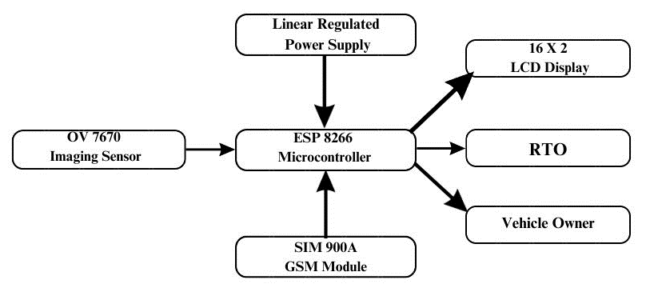
Fig. 2- Block Diagram of Proposed System
The overall system is based on ESP32 CAM Wi-Fi module used for the interfacing the imaging sensor on to the model for the image recognition process. The Wi-Fi, conventional Bluetooth, and BLE Beacon are all integrated into ESP, which also features two powerful 32-bit LX6 CPUs [18], [19]. It has an on-chip sensor, a Hall sensor, a temperature sensor, etc. in addition to its main frequency adjustment range of 80MHz to 240MHz. The 0.3MP OV7670 camera module with High-Quality Serial Camera Control Bus Connector is a low voltage CMOS image sensor offers a single-chip Video Graphics Array. The overall system is connected and the attached with this microcontroller and the power supply used to provide the power to the all devices for the work. The 16X2 LMD 16L LCD display is used to show which number is detected and then the message is send to the owner of the vehicle as well as to RTO based on violation of traffic rules through SIM900A GSM module.
The interfacing circuit diagram of Microcontroller, imaging sensor, LCD and GSM module is shown in Fig. 3.
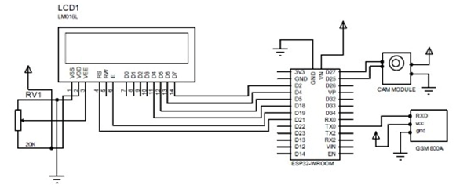
Fig. 3- Interfacing Circuit diagram of proposed system

- POWER SUPPLY AND PCB DESIGN
We have designed linear regulated DC power supply having three different DC voltage rating viz. 5V and 3.3 V. The single phase AC supply is taken from Distribution Section of Electricity Board. It is 230 V, 50 Hz alternating current obtained through Line & Neutral Points from socket-board.
We designed transformer based on dropout voltage across regulator IC (of 2 V) and 4 rectifier diodes (0.7 V across each). The total voltage Drop = 2 V + (0.7 + 0.7) = 3.4 V. Thus, Secondary Voltage = Vo + Voltage Drop = (12 + 3.4) V = 15.4 V ~ 15 V. Also, the secondary current = (Vrms / RL) = 15 / 12 = 1.25 A. ~ 2 A. Finally, the transformer Rating is : Step Down, 15 V, 2A.
As we discussed various types of rectifiers, but from that we will choose Bridge Rectifier as it has high efficiency, less ripple factor value & very important parameter is Less PIV (Peak Inverse Voltage). Bridge rectifier consists of 4 Rectifier Diodes. For that we have to know its PIV. For Bridge Rectifier, PIV = Vm = √2.
Vrms = √2 × 15.4 V = 21.77 V (1)
Also, maximum current handling capacity is I_{sec} = 1.25 A ~ 2 A. The Diodes having PIV rating & maximum current handling capacity I_{sec} near to calculated values must be selected. From datasheet, we can use Diode 1 N 4007 as rectifier diode in Bridge Rectifier Circuit.
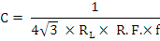Filter capacitor is used to get pure ripple free DC voltage. Ripple factor of diode 1 N 4001 is 0.48. Based on below formula in eq. (2), we designed the capacitor filter:
(2)

The ripple factor for bridge rectifier is 0.48 and frequency is 50 Hz. After solving the eq. (i), the capacitor filter of value 500 μF or higher rating is used (In our case 1000 μF electrolytic capacitor is used).
Now, if filter circuit is far away from regulator then some distortion in waveform will be present there. To overcome these distortions in waveform due to transmission, we can use capacitor C1 of 0.1 µF. Also we use C1 as 10 µF on output side to improve transient response of system. When there is sudden change in current voltage Vo tries to decrease & tries to reduce time required to stabilize. We used 7805 and LM1117 voltage regulator IC to obtain positive 5V (for GSM, Imaging Sensor and LCD) and 3.3 V (for ESP32 microcontroller) respectively. The complete power supply design is shown in Fig. 4.
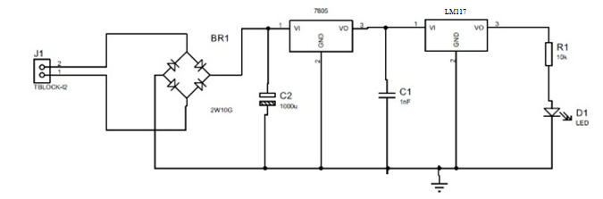
Fig. 4- Design of Power Supply to get 5 V and 3.3 V
We tested and troubleshoot the power supply design and interface it with microcontroller and LCD up till now. The PCB artwork and layout is designed using Proteus software and the 3-D visualization of the same is shown in Fig. 5.
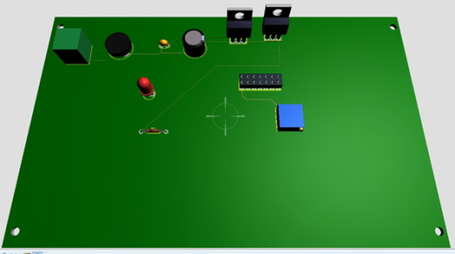
Fig. 5- 3-D visualization of Power Supply Design
The hardware setup for experimentation is shown in Fig. 6 in which 3 different ratings of voltages have been implemented viz. 12 V (future development), 5 V and 3.3 V.
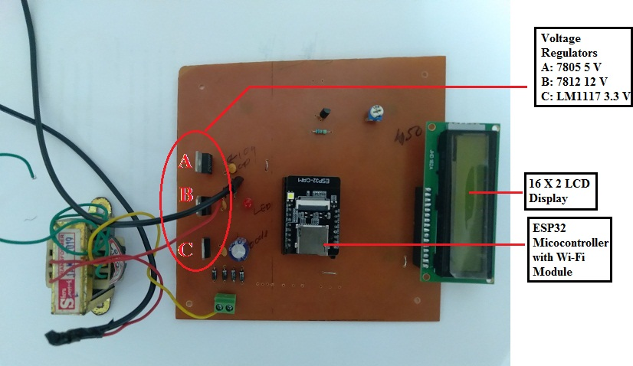
Fig. 6- Hardware Set-up of proposed system
For experimentation purpose, we used Core2Duo CPU with 2GHz processor and 3 GB RAM as computing platform for image processing operation. In our experimentation, the vehicle image is captured which is in steady state by using OV7670 as shown in Fig. 7.
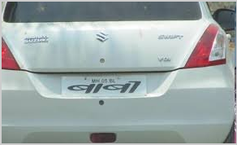
Fig. 7- Rear view of Vehicle having fancy number plate [20]
The edge based number plate detection algorithm is used to identify the location of vehicle number plate from rear view of complete vehicle. This method is easy and obtained the resultant image speedily which is shown in Fig. 8.
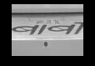
Fig. 8- Localization of Vehicle Number Plate
The USB micro to TTL is used to interface the system with ESP32 microcontroller. As this is our ongoing project the character recognition part in process to recognize the numbers from fancy vehicle number plate.
- CONCLUSION
The approaches and strategies currently being employed in vehicle number plate detection solutions in recent literature have been examined and analyzed in this survey work. This paper presented the Devanagari script based Fancy vehicle number plate recognition methodology. We implemented the system using ESP32 microcontroller, OP7670 imaging sensor, SIM900A GSM module. The complete power supply with specified rating is designed followed by simulation of vehicle number plate localization from complete view of vehicle. In future, the synthetic dataset will be prepared and training and testing of machine learning algorithms will be accomplished to obtain the exact character from fancy number plate with higher accuracy.

REFERENCES
- Simon Mutua, Kaibiru Mutua and Bernard Shibwabo, "An Automatic Number Plate Recognition System for Car Park Management", International Journal of Computer Applications, Vol. 175, No. 7, October 2017. DOI: 10.5120/ijca2017915608.
- Different Types of Number Plates in India. Available online at https://www.godigit.com/traffic-rules/different-types-of-number-plates Last accessed on 17 March 2023
- Car Number Plate in India: A definitive Guide to RTO Number Plate. Available online at https://www.turtlemint.com/vehicle-number-plate/ Last accessed on 17 March 2023
- Statutory Plates and Inscriptions for Motor Vehicles, their Location and Method of attachment – Vehicle Identification Numbering System Ministry of Road Transport & Highways, Government Of India, 18th February 2017. Available online at https://morth.nic.in/sites/default/files/ASI/531201714455PMAIS-065_and_Amd_1_to_3.pdf Last accessed on 17 March 2023
- Siddhanth Tripathi, Somil Jain, Sinchana Shetty and Vanshika Sharma, "Automatic Number Plate Recognition System (ANPR): The Implementation", International Journal of Innovative Technology and Exploring Engineering (IJITEE), Vol. 10, No. 8, June 2021, DOI: 10.35940/ijitee.H9257.0610821.
- Li Cuimei, Qi Zhiliang, Jia Nan and Wu Jianhua, "Human Face detection algorithm via Haar cascade classifier combined with three additional classifiers", IEEE International Conference on Electronic Measurement & Instruments (ICEMI), 20-22 October 2017, Yangzhou, China. DOI: 10.1109/ICEMI.2017.8265863.
- Muhammad Tahir Qadri and Muhammad Asif, "Automatic Number Plate Recognition System for Vehicle Identification Using Optical Character Recognition", International Conference on Education Technology and Computer, 17-20 April 2009, Singapore, DOI: 10.1109/ICETC.2009.54.
- Ravindra Rajaram Patil, Omkar S. Vaidya, Gayatri M. Phade and Sanjay T. Gandhe, "Qualified Scrutiny for Real-Time Object Tracking Framework", International Journal on Emerging Technologies, Vol. 11, No. 3, pp. 313-319, May 2020.
- Omkar S. Vaidya, Ravindra Rajaram Patil, Gayatri M. Phade, Sanjay T. Gandhe, "Embedded Vision Based Cost Effective Tele-operating Smart Robot", International Journal of Innovative Technology and Exploring Engineering, Vol. 8, No. 7, pp. 1544-1550, May 2019.
- Vimal Bodke and Prof. Omkar S Vaidya, "Object Recognition in a Cluttered Scene using Point Feature Matching", International Journal for Research in Applied Science & Engineering Technology, Vol. 5, No. IX, pp. 286-290, September 2017.
- Sushant Poojary, Manthan Naik Gaunkar, Babani Dessai, Manju Ayalli, Vijay Kumar Naik Pawar and Shailendra Aswale, "Deep Learning Methods for Automatic Number Plate Recognition System: A Review", International Conference on Intelligent Engineering and Management (ICIEM), 27-29 April 2022, London, United Kingdom.
DOI: 10.1109/ICIEM54221.2022.9853092.
- Omkar S. Vaidya and Dr. Sanjay T. Gandhe, "The Study of Preprocessing and Postprocessing Techniques of Image Stitching", IEEE International Conference on Advances in Communication and Computing Technology, pp. 431-435, 8-9 February, 2018, AVCOE, Sangamner, DOI: 10.1109/ICACCT.2018.8529642.
- L. Luo, H. Sun, W. Zhou, and L. Luo, “An efficient method of license plate location”, in Proc. 1st Int. Conf. Inf. Sci. Eng., 2009, pp. 770–773.
- T. Duan, D. Tran, P. Tran, and N. Hoang, ‘‘Building an automatic vehicle license-plate recognition system,’’ in Proc. Int. Conf. Comput. Sci., Feb. 2005, pp. 59–63.
- C.-T. Hsieh, Y.-S. Juan, and K.-M. Hung, ‘‘Multiple license plate detection for complex background,’’ in Proc. 19th Int. Conf. Adv. Inf. Netw. Appl. (AINA), vols. 1–2, 2005, pp. 389–392.
- Jithmi Shashirangana, Heshan Padmasiri, Dulani Meedeniya and Charith Perera, Automated License Plate Recognition: A Survey on Methods and Techniques", IEEE Access, Vol. 9, pp. 11203 - 11225, DOI: 10.1109/ACCESS.2020.3047929.
- Muhammad Gufran Khan, Salma, Maham Saeed, Adil Zulfiqar, Yazeed Yasin Ghadi and Muhammad Adnan, "A Novel Deep Learning Based ANPR Pipeline for Vehicle Access Control", IEEE Access, Vol. 10, pp. 64172 - 64184, DOI: 10.1109/ACCESS.2022.3183101.
- Omkar Vaidya, Varsha Ramesh Nadar, Vishal Satish Bhosale, Sanjay Gandhe, Gayatri Phade and Pravin Ashok Dhulekar, "E-Governance System for Traffic Infringement Using Automatic Vehicle Number Plate Recognition", Multicon-W 2020 Proceedings McGraw Hill Education (India) Private Limited, ISBN: 978-93-90385-79-9, pp. 95-100, 28-29 February, 2020
- Dr. Gayatri Phade, Krishna Nandkumar Goverdhane, Omkar S. Vaidya and Dr. Sanjay Gandhe, "A Novel ICT Tool For Interactive Learning For Electronics Engineering Based On Augmented Reality", International Journal of Scientific & Technology Research, Vol. 8, No. 8, pp. 1886-1893, August 2019.
- Sample Fancy Vehicle Number Plate: Available online at https://www.team-bhp.com/forum/street-experiences/2694-take-look-number-plate-23.html Last accessed on 17 March 2023.

