Healthcare System for Scheduled Medicine Dispensing and Reminder for Elderly People
Arish Krishna Elavarasan¹, Aravinth Panchanathan², Abinesh Govindharaj³ Akash Kaliyaperumal⁴, Subhashini Neelamegam⁵
¹UG student,²UG student,³UG student,⁴UG student,⁵Asst. Professor
SRM Valliammai Engineering College, Chengalpattu, India, 603203
¹arishkrishna152002@gmail.com, ²paravinthpanchanathan@gmail.com, ³abineshg2@gmail.com, ⁴akashk18022002@gmail.com,⁵ subhashini.nk@gmail.com

Received on: xxxx,20xx, Revised on: xxxx,20xx, Published on: xxxx,20xx

Abstract— The recent growth in technologies was extended into the field of health care to ease the approach towards the medical diagnosis and treatment. After the treatment the medication at right time is essential for the disease to get cured. In general, the patients may forget to take their pills at right time, and some people missed to take the medicines at an appropriate time because of their busy work schedule. The proposed system facilitates such persons by providing an alert according to the dosage schedule and in addition to this dispense the correct medicine as per the prescription to the concerned person with disability. The proposed system consists of a smart medicine box that is designed to help elderly patients taking their medications on time. The main feature of the proposed model is the automatic opening of the box and alarm will be raised to alert the patient to take the medicine. Another distinct feature is a mobile application is associated with the system which gives the privilege to the caretaker of patients to check and program the medicine box as per the medical prescription of the doctor. If the person under care does not take medicine even after the medicine is being dispensed, the caretaker will be informed via the mobile application to remind the patients manually. When the medicine box becomes empty the system will inform the caretaker through message to the registered mobile number to refill the pill box for further usage. Apart from the medication to the patients at right time, the entire data related to the patient will be available in the cloud for the convenience of assessment of patient health condition at any time. Thus, the proposed system will aid the people to monitor their health with right medication.

Keywords— dosage, pill box, medicine dispensing, reminder, schedule.

INTRODUTION
The Chronic morbidity is associated with ageing, mandating the follow up of the complicated drug schedules. Seniors and older people often find it difficult to follow complicated medication routines, due to the impaired eye sight and memory[1] . Some people might forget to take their medications at the right moment or do not remember what medications they need to take. To improve the intake of correct medicines at the right schedule and to monitor the elderly people even in the absence of the care takers, the automatic medicine dispenser can be a simple, transportable, and effective solution. Medication retention also depends on monitoring and for patients' and family members' safety and effectiveness, it's critical to accurately record drug usage. There may be many people out there who require continuous assistance, including the elderly, family members, and people with special needs. Elders are more sensitive to the timing of a drug's administration than other people, so timing is crucial for avoiding any dysfunction or ailment [2].The complex blend of medications consumed taken at specific times throughout the day along with a variety of directions arises if they have severe medical conditions or chronic illnesses in some of the patients.
In addition to the systematic medication, aged people may experience various degrees of impairment, which makes it extremely challenging for them to remember when and how to take their medications. There are many causes of medication non-adherence, which is a severe issue. A patient's medication regimen may have been incorrect, or they might have taken their medications at the inappropriate time of day. Another possibility is that not taking medication as directed by the physician, sometimes having medications irrelevantly might be life threatening. To manage their medicine, patients have a number of options. They might begin with a basic pill box. They might require a small reminder on when to take the suggested medication when their pharmaceutical routine becomes more complicated. Patients begin to seek assistance from caregiver, such as a family member or a qualified health care practitioner, when their cognitive function deteriorates.

RELATED WORK
The causes of medicine non-adherence are observed and explored in the approaches that have been proven to improve the prescribed schedule. A framework for using this knowledge, and analysing the current research to identify promising future lines of inquiry was discussed in [3]. The Aged people's independence in daily routines and medication adherence were enhanced by audio and visual reminders and pre-planned medication. Analysis of the medicine dosage conformability with elderly people and the technological update with the system modelled for medicine dispensing was explored in this article[4]. A systematic review was conducted on the features and adherence of the prescribed schedule of the various systems designed for medicine dispensing [5]. An android application was designed to notify elder people about the timing and the prescribed drugs with alarm. The alarm can be put off once the person had the pill, this system avoids missing tablet consumption[6]. The article [7] focuses on the conceptualization, design, and development of a prototype pillbox that addresses this medical need by automatically sorting pills among its many other high-tech capabilities. The gadget is designed for use in hospitals or retirement communities.
A model was proposed that automatically administers dosage of medicines to patients and elderly individuals so that they are conveyed about their medications as directed by the doctor [8]. To implement this, pre-setting the specified time and comparing it to RTC time are used, and the tablets are given out of the system once the timings are equal. The proposed automatic medication dispenser makes the patients to experience a more personalized treatment and offers the best effective approach to keeping track of the medications taken even when the patient is in a remote place. This initiative in [9] demonstrated the usefulness and potential of IoT devices in addressing the challenges that patients have when taking drugs. To cut down on labour costs and the chance of errors, an automatic dispensing system for Chinese herbal decoctions was proposed in [10]. To make it easier to grab ingredients, a robot manipulator with machine vision is used and a human-computer interface is used to input the name and recipe of the decoction, and several medicinal packets are automatically dispensed. In the model discussed in the article [13], based on the schedule the pills filled in the pill dispenser will be dispensed with an alarm, which overcomes the continuous monitoring of the patient by the caretaker. In this paper [11] a smart pillbox is proposed that can notify family members remotely if an elderly person has taken their medication and can remind them to do so on time.
In light of the developing healthcare sector, the article [12] puts forth Body Edge, a unique design best suited for human-centric applications, to gather and locally analyse data from various scenarios. The pill box has a mobile app that allows the person responsible for looking after elderly people to inspect and program the device [13]. A time-based medicine dispenser is proposed in [14] based on the prescription of the medical practitioner the medicine will be dispensed automatically to the patient. The opportunity to collect reliable patient data automatically allows for to enhancement of patient self-management and helps in better delivering therapies. In this paper, authors propose an innovative architecture for a smart pill dispenser enhanced by a smart device that furnishes the capability of automatically identifying the user, other than logging medicine in-take activities [15].
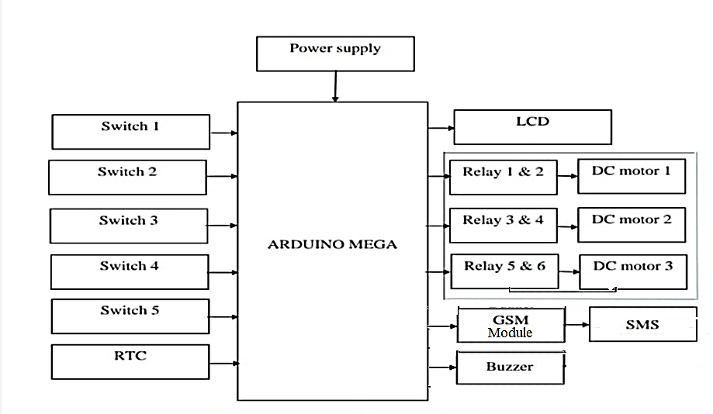
Fig.1.The Block diagram of the proposed model

SYSTEM MODEL
The recent growth in technologies was extended into the field of health care to ease the approach towards the medical diagnosis and treatment. The main feature of the proposed model is the automatic opening of the box and alarm will be raised to alert the patient to take the medicine. Another distinct feature is a mobile application is associated with the system which gives the privilege to the caretaker of patients to check and program the medicine box as per the medical prescription of the doctor. If the person under care does not take medicine even after the medicine is being dispensed, the caretaker will be informed via the mobile application to remind the patients manually. When the medicine box becomes empty the system will inform the caretaker through message to the registered mobile number to refill the pill box for further usage.
An Adherence to the medication time prevents many complications in the patients especially in the persons suffering from the chronic disease. The main objective of the proposed system is to provide a complete care to the patient who is under treatment as well as to the elderly people in home. In the block diagram shown in Fig.1 illustrates the essential building blocks of the proposed system.

Working Principle
Three trays are used to hold the pills for the morning, afternoon, and night sessions which is being controlled by the DC motors. Depending on the prescription given by the medical practitioner, the time for consuming the tablets can be set using a switch manually. As per the preset value, the tray will open with the help of the DC motor. Once the desired time is reached, the tray remains open to allow the user to have the medicine in the tray. After consuming the medicine, the user has to close the tray manually if not alarm will be raised.
In the other case if the user did not take medicine but the tray remains open for five minutes then also the alarm raises. If such a condition arises, intimation in the form of SMS will be sent to the caretaker. Thus, the proposed system provides safe monitoring of the patients, by alerting the caretaker when the pills are not consumed by the patient as well as the quantity of the in the tray. Hence the quantity of the pills in the tray is monitored and a refill of the same can be done before the tray becomes empty completely.

Hardware Implementation
The hardware implementation of the proposed model is shown in Fig. 2 illustrates the integrated system which satisfies the medicinal adhesion of the patient. The medicine tray is loaded with the required quantity of medicines. In the three trays, where each tray is used for forenoon, afternoon and night respectively, the medicines are filled.
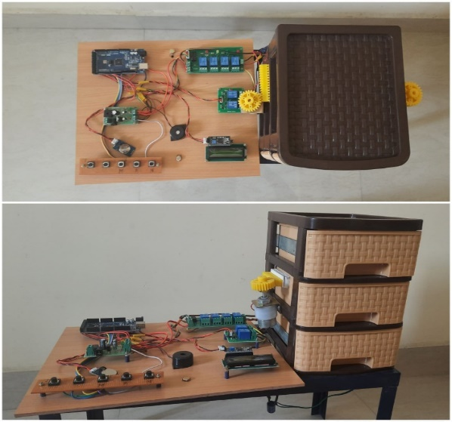
Fig. 2. Hardware implementation of the medicine dispenser
The medicine dispenser is programmed as per the prescription and the tray containing pills is opened accordingly. If the user is not responding even if the tray remains open for more than 5 minutes the alarm is raised. The GSM module is attached to the medical dispenser to send an alert message to the caretaker under circumstances when the user did not consume the medicine and the quantity of the medicines in the tray is low.

OUTPUT
The hardware implemented of proposed system is tested for the desired output and the data is monitored by the care taker from the remote place.
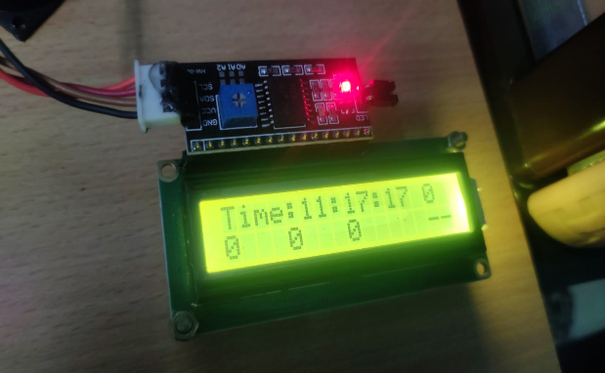
Fig.3. Presetting of the schedule for medicine dispensing
The Fig.3 show the display of the time set for opening the tray. The Arduino is interfaced with the DC motor is used to open the tray according to the instruction received.
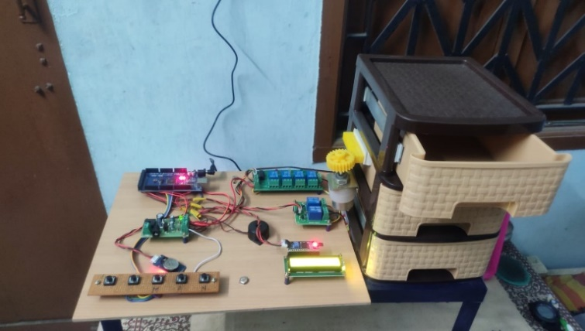
Fig.4. Dispensing of medicine for the morning
The buzzer is used to raise an alarm to alert the patient to take the tablet at right time. Once the time is set, the tray will open as per the scheduled time as shown in Fig.4. The patient can take the pill from the box and close the box. Very low power is required for the execution of the proposed model and the system works effectively in assisting the patient and the elderly people.
Even if caretaker is not near to the person, with the help of the GSM module, an alert message can be sent to the caretaker informing about the status of the quantity of the pills if it is less and if the tray remains open indicating that the patient did not consume medicine.

CONCLUSION
The proposed model meets the need of the elderly people as well as patients who were in need of assistance or nursing care in taking pills at right time. Due to the aging, a person with poor memory may miss to have the tablet at right time and in right quantity. This proposed model serves as a solution for such problems among elderly people. The cost effective, easy to use system can serve and save many people. As a future enhancement, the quantity of the pills can be made available in cloud, which can be continuously monitored, and necessary actions can be taken spontaneously.

REFERENCES
- Diaa Salama Abdul Minaam, Mohamed Abd-ELfattah, “Smart drugs:Improving healthcare using Smart Pill Box for Medicine Reminder and Monitoring System”,Future Computing and Informatics Journal,vol. 3, no.2,pp 443-456, 2018.
- Murtadha Aldeer, Richard E. Howard, Richard P. Martin, Jorge Ortiz, “Unobtrusive patient identification using smart pill-bottle systems”,Internet of Things,vol.14,2021.
- Kathy Henley Haug, “Medication Adherence in Older Adults: The Pillbox Half Full”, Nursing Clinics of North America,vol.49, no.2,pp 183-199,2014.
- Armghan Ahmad Venus Chiu Mubashir Aslam Arain, “Users' Perceptions of an in-Home Electronic Medication Dispensing System: A Qualitative Study“,Medical Devices: Evidence and Research, vol. 13, pp 31-39, 2020.
- Sadaf Faisal,Jessica Ivo, Tejal Patel, “A review of features and characteristics of smart medication adherence products”, sage publications, Vol.154, no.5,pp 312-323, 2021.
- R.M. Thadi, Uma Shankar Bhagat, Shwet Raj, “Automatic Pill Dispenser Robot”, Zeichen Journal, vol. 6, no.6, pp 36-38,2020.
- Abdul Minaam DS, Abd-ELfattah M, “Smart drugs:Improving healthcare using Smart Pill Box for Medicine Reminder and Monitoring System”, Future Computing and Informatics Journal, https://doi.org/10.1016/j.fcij.2018.11.008, 2018.
- S. R. Bhagya Shree, P. Chandra Shekar, A. Arjun, G. R. Manoj, A. Nithin and R. S. Raj, "Automated medication dispensing system," 2014 Eleventh International Conference on Wireless and Optical Communications Networks (WOCN), Vijayawada, India, 2014, pp. 1-6, doi: 10.1109/WOCN.2014.6923079.
- Nanda Kishor Panda, Shubham Bhardwaj, H.Bharadwaj, Rohil Singhvi, “IoT based Advanced Medicine Dispenser Integrated with an Interactive Web Application”,International Journal of Engineering & Technology, vol.7 (4.10), pp 46-48 ,2018.
- Liu, Yi-Hung,Lin, Chi-Ying,Hsieh, Ping-Jung, "Development of an Automatic Dispensing System for Traditional Chinese Herbs",Journal of Healthcare Engineering,https://doi.org/10.1155/2017/9013508, 2017.
- P. -H. Tsai, T. -Y. Chen, C. -R. Yu, C. -S. Shih and J. W. S. Liu, "Smart Medication Dispenser: Design, Architecture and Implementation," in IEEE Systems Journal, vol. 5, no. 1, pp. 99-110, March 2011, doi: 10.1109/JSYST.2010.2070970.
- P. Pace, G. Aloi, R. Gravina, G. Caliciuri, G. Fortino and A. Liotta, "An edge-based architecture to support efficient applications for healthcare industry 4.0", IEEE Trans. Ind. Informat., vol. 15, no. 1, pp. 481-489, Jan. 2019.
- Mrityunjaya D, Kartik J, Teja B, Kotresh Hiremath, "Automatic Pill Dispenser" Intl. Journal of Advanced Research in CCE July 2016.
- Shinde Suraj, Bange Nitin, Kumbhar Monika, Patil Snehal, “Smart medication dispenser”, Int J Adv Res. Electron Commun Eng, vol. 6, no. 4, April 2017.
[15] C. Crema, A. Depari, A. Flammini, M. Lavarini, E. Sisinni and A. Vezzoli, "A smartphone-enhanced pill-dispenser providing patient identification and in-take recognition," 2015 IEEE International Symposium on Medical Measurements and Applications (MeMeA) Proceedings, Turin, Italy, pp. 484-489,2015.

