Identification of Tomato Leaf Disease Prediction Using CNN

Suraj Kushwaha¹, Dr. Shrikant Zade²
¹Student, ²Associate Professor
Oriental Institute of Science & Technology, Bhopal (M.P.)

suraj21kushwaha@gmail.com
Received on: 11 June ,2022 Revised on: 28 July ,2022, Published on: 01 Augusr,2022

Abstract – Tomatoes are the most extensively planted vegetable crop in India's agricultural lands. Although the tropical environment is favorable for its growth, specific climatic conditions and other variables influence tomato plant growth. In addition to these environmental circumstances and natural disasters, plant disease is a severe agricultural production issue that results in economic loss. Therefore, early illness detection can provide better outcomes than current detection algorithms. As a result, deep learning approaches based on computer vision might be used to detect diseases early. This study thoroughly examines the disease categorization and detection strategies used to identify tomato leaf diseases. The pros and limitations of the approaches provided are also discussed in this study. Finally, employing hybrid deep-learning architecture, this research provides an early disease detection approach for detecting tomato leaf disease.

Keywords- Artificial Intelligence, Convolutional Neural Network (CNN), deep learning, crop disease, tomato leaf.
I-INTRODUCTION
Precision farming is the next step in the evolution of agriculture. Precision agriculture may boost agricultural output by combining science and technology. Precision farming also entails reducing pesticides and illnesses by accurately calculating the number of pesticides needed. Precision farming has improved several agriculture sectors as it transitions from conventional ways to new approaches. Precision farming's only objective is to obtain real-time data to boost agricultural yield and maintain crop quality.
Agriculture is much more than just a means of feeding the world's growing population. Plant diseases have also cost agricultural and forestry businesses a lot of money. As a result, early identification and diagnosis of plant diseases are crucial to take fast action.
A variety of methods can be used to identify sickness in plants. On the other hand, certain illnesses are difficult to detect early on. Therefore, they will have to wait a little longer to figure out what is going on. Advanced analysis, which is often done with powerful microscopes, is necessary under these conditions. Furthermore, diseases wreak havoc on a plant's overall health, slowing its development. Unfortunately, a plethora of tomato diseases is wreaking havoc on the leaves of the crop. The proposed study's primary objective is to find a solution to the problem of identifying tomato leaf disease using the most straightforward technique feasible while utilizing the fewest computer resources necessary to achieve results comparable to state-of-the-art alternatives. In addition, to assist in classifying input photos into sickness classifications, automatic feature extraction is applied. Consequently, the suggested system attained an average accuracy of 94%-95%, demonstrating the neural network approach's viability even under challenging scenarios. Sensors and remote sensing, mapping and surveying, high-precision positioning systems, variable rates, the global navigation satellite system, automated steering systems mapping, computer-based applications, and other technologies are all used in precision agriculture. In addition, precision agricultural concepts based on infrared variation analysis and treatment are also cutting-edge technologies. This examination utilizes a more modest adaptation of the convolutional neural organization model to recognize and analyze messes in tomato leaves. In other cases, the signals can only be detected in non-visible electromagnetic spectrum areas. This research aims to develop a user-friendly method that will aid farmers in recognizing tomato plant issues without having to consult an expert. We first obtain a picture from the Kaggle dataset, from which we extract characteristics. Then, to remove the attributes, we employ picture conversion and scaling. Finally, to diagnose diseases, the CNN model will be used.

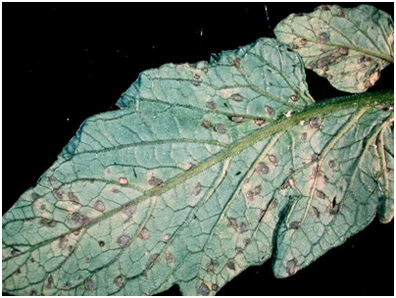
Fig 1-Infected Leaf
II- IMAGE PROCESSING IN PRECISION AGRICULTURE
Precision agriculture uses deep learning techniques, and its approach to crop protection effectively boosts crop development. Image analysis may be used to detect the sick leaf and measure and locate the damaged area's border to identify the item appropriately. This study develops an improved deep learning system for determining the state of a tomato crop based on a photo of its leaves.
We all know that the human brain recognizes images far faster than a computer. However, the era has changed with the introduction of Machine Learning. High performance on image identification tasks may be ensured using the model, deep convolution neural network, which can surpass human performance in several domains. By certifying their work against Image Net, researchers have achieved advances in the field of visual recognition.
SYMPTOMS OF TOMATO LEAF DISEASE:
The plant's color, shape, and function may vary as it responds to the illness. We'll go through the signs and symptoms of these illnesses, as well as what to check for if your plant's development appears to be slow. The appropriate classification and diagnosis of leaf diseases are crucial for reducing agricultural losses. Different plant leaves transmit various diseases and show other symptoms.
Leaf Bacterial spot:
Bacterial leaf spot is caused by four species of Xanthomonas. It infects all varieties of tomato and in the Midwest it causes moderate to severe damage on tomato fruit making then non-marketable due to quality issues. Symptoms include leaf lesions with yellowing and large crusty spots on the fruit.
Leaf Mold:
Production of tomatoes under high tunnel and plastic has increased significantly over the last few years in part due to consumers demand for “local” produce. Even though growing under these conditions can reduce the occurrence of some diseases, it can increase the occurrence of others. Tomato leaf mold disease is one that’s showing a significant increase. It’s caused by a fungus formerly known as Cladosporium fulvum, but now known as Fulvia fulva by producers and those in the seed trade, and Passalora fulva by mycologists. The disease is rarely seen on field-grown plants, and when it’s observed in the field, it’s due to infected greenhouse-grown transplants.
Spider_mites Two-spotted_spider_mite:
The two-spotted spider mite is the most common mite species that attacks vegetable and fruit crops in New England. Spider mites can occur in tomato, eggplant, potato, vine crops such as melons, cucumbers, and other crops. Two-spotted spider mites are one of the most important pests of eggplant.
Target_Spot:
Target spot on tomato fruit is difficult to recognize in the early stages, as the disease resembles several other fungal diseases of tomatoes. However, as diseased tomatoes ripen and turn from green to red, the fruit displays circular spots with concentric, target-like rings and a velvety black, fungal lesion in the center. The “targets” become pitted and larger as the tomato matures.
Yellow_Leaf_Curl_Virus:
Tomato yellow leaf curl virus (TYLCV) is a DNA virus from the genus Begomovirus and the family Geminiviridae. TYLCV causes the most destructive disease of tomato, and it can be found in tropical and subtropical regions causing severe economic losses.
Tomato_mosaic_virus:
Tomato mosaic virus symptoms can be found at any stage of growth and all parts of the plant may be infected. They are often seen as a general mottling or mosaic appearance on foliage. When the plant is severely affected, leaves may look akin to ferns with raised dark green regions. Leaves may also become stunted.
Leaf Spot on Septoria:
One of the most prevalent tomato plant leaf diseases is the septoria leaf spot. A tiny, round patch with a greyish-white centre and black borders is the first sign of this fungus' presence. In the centre, tiny black specks may appear. The leaves of sensitive tomato plants become yellow, wither, and fall off due to prolonged exposure to hot, humid conditions.
Early Blight (Alternaria):
Alternaria is a parasite that causes tomato leaf spots and an early curse. On the lower leaves, brown or dark regions with dim edges arise, practically like an objective. Organic product stem closes are exceptionally touchy, creating tremendous, profound dark blotches with concentric rings. A fungus causes this tomato plant disease, which appears after the plants have produced fruit.
Blight in the Late Stages:
Late blight, a tomato plant disease caused by the fungus Phytophthora infestans, arises in perfect, wet conditions after the growth season. Frost damage with uneven green-black splotches emerges on plants. Fruits with large, irregularly shaped black areas can quickly be destroyed. This fungus, which causes tomato plant disease, also affects potatoes and can be transmitted through them. The same precautions should be used as with septoria leaf spot.

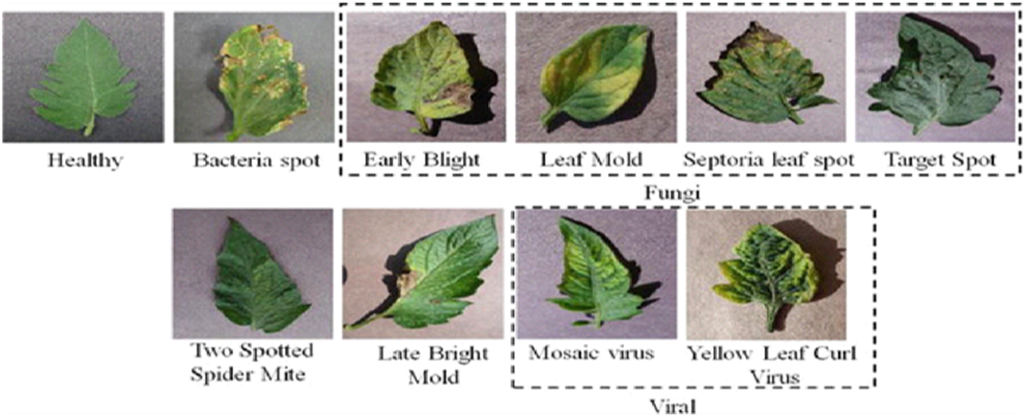
Fig 2. Tomato Healthy and Types of Diseases
Machine Learning:
Artificial intelligence is a sort of machine learning. Without being coded, a system learns from its past experiences and improves. Instead, it concentrates on

developing the computer program such that the data accessed may be used for self-learning.
Deep Learning:
Deep learning is a subset of machine learning that excels in finding patterns in massive volumes of data. Object detection from images, for example, is achieved using three or more layers of artificial neural networks, each of which extracts a large number of visual properties.
Neural Network:
A computer model works similarly to neurons in the human brain. Each neuron accepts an input, acts on it, and then passes the findings to the next neuron.
Deep Convolution Neural Network :
As an information processing paradigm, the neural network was inspired by the biological nervous system. It comprises a large number of neurons, which are densely coupled processing components that generate a series of real-valued activations. For example, when given input, early neurons are activated, and weighted connections from previously active neurons activate other neurons.
Depending on how neurons are employed and coupled, large causal chains and links between computational stages may be required. Deep neural networks (DNNs) are neural networks with a large number of hidden layers.
As a result of its growth, Deep Learning has made significant progress in image classification. Deep learning algorithms aim to learn the feature hierarchy automatically. At different degrees of deliberation, this self-learned component permits the framework to dissect complex contributions to yield planning capacities straightforwardly from getting to information without depending on human-made highlights.
How CNN Works?
A Convolution, Neural Network layers include Convolution, ReLU Layer, Pooling, Fully Connected, Flatten, and Normalization. The photographs would be compared piece by piece using CNN. The item is referred to as a feature or filter. CNN employs the weight matrix to extract particular characteristics from the input picture without losing information about the image's spatial organization. CNN adheres to the following layers:
The layer of Convolution is the first layer. It aligns the feature and picture before multiplying each image pixel by the feature pixel. After completing the multiplication of the associated matrix, CNN adds and divides the result by the total number of pixels, creates a map, and places the filter's value there. The feature is then moved to every other place in the picture, and the matrix output is obtained. Next, the process is repeated for the other filters.
Thus, this layer repositions the filter on the picture in every conceivable location.
1. ReLU Layer:
2. ReLU is an acronym for Rectified Linear Unit
3. Every negative value in the filter pictures will be eliminated and replaced with zeros in this layer. The function only activates a node when the input is zero and the output is zero. However, the dependent variable has a linear connection if the information grows. Thus, it enhances the neural network by increasing the amount of training.
4. Polling Layer:
5. This layer reduces the size of the picture by extracting the maximum value from the filtered image and converting it to a matrix. It also keeps overfitting at bay.
6. All Fully Connected Layer
7. This is the final layer of CNN, and it is here that the absolute categorization takes place. First, a single list is created with all of the filtered and compressed photos.
III- EXPERIMENT
A. DATA DESCRIPTION
We use the Kaggle dataset as the basis for the evaluation of the leaf health recognition task.
The dataset is divided into two parts:
11000 total images in the dataset, Total testing & Total training images: Data is split in 90/10 atio, i.e. 90% or training and 10% Tomato mosaic virus symptoms can be found at any stage of growth and all parts of the plant may be infected. They are often seen as a general mottling or mosaic appearance on foliage. When the plant is severely affected, leaves may look akin to ferns with raised dark green regions. Leaves may also become stunted testing samples are used for training the deep neural network. The dataset allows machine learning researchers with fresh ideas to go right into a critical technological area without gathering or generating new data sets, allowing for a direct comparison to the efficacy of earlier work. The data collection is created using the Leaf picture, which includes healthy and unhealthy individuals of various classes. The data set is split into two sections: one huge group is utilised for training the deep neural network, and another sample is used to validate the model.
Finally, a set known as the test set is employed. All models and training are done with the Keras with TensorFlow as a deep learning library using high-end GPUs such as T4 and P100 and TPUs. The Adam optimizer was used for all architectures, and the loss function was the categorical cross-entropy function... We also used ReLU activation functions for all layers, except the last dense layer.
B. THE METHOD OF EVALUATION:
In This paper, we have built a DCNN from scratch:
- Our DCNN model contains one input layer, multiple conv2D layers, 2 Dense layers, and one output layer with a few dropout layers in between.
- On the training and Validation dataset, the DCNN model is trained.
- After training, true-positive, false-positive, accurate- negative, false-negative of the test set were recorded successively.
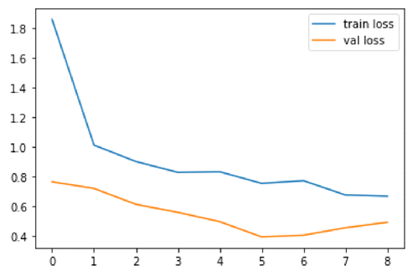
Fig 3- Training vs Validation loss of CNN Model loss of CNN Model
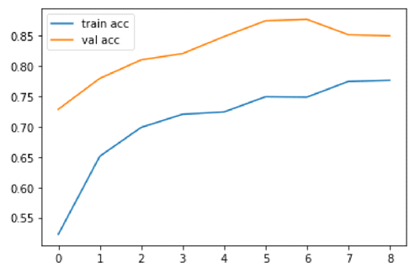
Fig 4- Training vs Validation loss of CNN Model
C. RESULT ANALYSIS AND DISCUSSION:
Our task was to train a deep convolutional neural network (CNN) to identify and classify leaf images. We used the Lead Disease Dataset from Kaggle, which we have selected in two categories [Diseased Leaf, Fresh Leaf], a dataset containing leaf images in the form of arrays from these two categories. Each category's leaf comes in a variety of leaf photos from various perspectives.
DL techniques continue to show great potential in increasing identification sensitivity and accuracy, particularly for short-term data. DCNN, on the other hand, can extract features automatically, saving time and effort. The findings are reported once the model has been evaluated on the test dataset. The model's overall accuracy is 96.6%.
When we build a model first time, the model tries to fit all the data that is why it has very low accuracy, so we reassign all the weighted data to your model so the model can run and reassign error then call the epoch of the model which is continuously running with data and try to increase accuracy and decrease the loss of the data. The accuracy result of our deep learning model clearly shows that when we grow the model epoch, there is an increment inaccuracy.
The accuracy result of our deep learning model clearly shows that when we increase the model epoch, there is an increment inaccuracy.
The model loss result clearly shows that when we increase the model epoch, Loss decreases.
IV. CONCLUSION
We project the classification through our system by deploying our model on a flask that observes illness and infected leaves. The project has several verticals in leaf detection. Up to now, we have achieved in sleuthing the disease-affected leaf. In the future, we will segregate the illness whether or not it is laid low with microorganisms, fungi, or infectious agents and specify the answer to the farmer within the field.
REFERENCE
[1] Agarwal, M., Singh, A., Arjaria, S.,Sinha, and Gupta, S., 2020. ToLeD: Tomato leaf disease detection using convolutional neural network. Procedia Computer Science, 167, pp.293-301.
[2] Sannakki, Sanjeev S., Vijay S.Rajpurohit,V.Nargund, and Parag Kulkarni are Sanjeev S. Sannakki, Vijay S. Rajpurohit, Vijay S. Rajpurohit, Vijay S. Rajpurohit, Vijay S "Using neural networks to diagnose and classify grape leaf diseases." 2013 Fourth International Conference on Computing, Communications, and Networking Technologies (ICCCNT), pp. 1-5 IEEE, 2013.
[3] Aida Sulinda, Suhaili Beeran, Noor Ezan Abdullah, Habibah Hashim, and Kutty “Using Neural Network Analysis to Classify Watermelon Leaf Diseases.” 459-464 in IEEE Business Engineering and Industrial Applications Colloquium (BELAC), 2013. 2013 IEEE.
[4] Arjun, K. M. (2013). Indian agriculture status, importance and role in the Indian economy. International Journal of Agriculture and Food Science Technology, 4(4), 343-346.
[5] Shrivastava, S, & Hooda, D. S. (2014). Automatic brown spot and frog eye detection from the image captured in the field. American Journal of Intelligent Systems, 4(4), 131- 134.
[6] Zhang, M., & Meng, Q. (2011). Automatic citrus canker detection from leaf images captured in the field. Pattern Recogni tion Letters, 32(15), 2036–2046.
[7] Jadhav, S. B. (2019). Convolutional neural networks for leaf image-based plant disease classification. IAES International Journal of Artificial Intelligence, 8(4), 328.
[8] Dashᵃ, J., Vermaᵃ, S., Dasmunshiᵃ, S., & Nigamᵃ, S. (2018). Plant Health Monitoring System Using Raspberry Pi. International Journal of Pure and Applied Mathematics, 119(15), 955-959.
[9] Patil, B., Panchal, H., Yadav, M. S., Singh, M. A., & Patil, M. D. (2017). Plant Monitoring using image processing, Raspberry Pi & IoT. International Research Journal of Engineering and Technology (IRJET), 4(10).
[10] Mhatre, R., & Lake, V. Cotton Leaves Disease Detection And Cure Using Deep Learning.
[11] By Sachin D. Khirade and A. B. Patil, "Plant Disease Detection Using Image Processing." ICCUBEA (International Conference on Computing, Communication, Control, and Automation) is a biennial international conference on computing, communication, control, and automation.), pp. 768-771. 2015, IEEE.
[12] Brahimi, M., Arsenovic, M., Laraba, S., Sladojevic, S.,Boukhalfa, K. and Moussaoui, A., 2018. Deep learning for plant diseases: detection and saliency map visualization. In Human and machine learning (pp. 93-117). Springer, Cham.

