**Vehicular Traffic Monitoring At City Intersection Using Probability**

**Jyoti M. Sapkale 1, Vijay D. Chaudhari 2, Dr. Anil J. Patil 3**

*1 M.Tech. (VLSI & Embedded System Design) Scholar 2 Asstt. Prof.*

*1,2 E&TC Engg. dept, GF’s Godavari College of Engg., Jalgaon-425003, Maharashtra, India.*

*3 Principal, Shri G. G. College of Engg , Jalgaon – 425003, India*

[*sapkalejyoti999@gmail.com1*](mailto:sapkalejyoti999@gmail.com1)*,* [*vinuda.chaudhari@gmail.com2*](mailto:vinuda.chaudhari@gmail.com2)*,* [*anilj48@gmail.com*](mailto:anilj48@gmail.com) *3*

***Abstract –****Nowadays, congestion in traffic is a serious issue all over the world. The traffic congestion is caused because of large red light delays. The delay of respective light is coded hardly in the traffic light and also it is not dependent on traffic density. The existing system varies the particular light delay time by taking the vehicle count using IR sensors which has several disadvantages. This project presents the system based on raspberry pi. It includes the high resolution camera.it captures images of vehicle, crowd of people. It perform the edge detection of vehicle and also people. It gives the separate count of vehicles and people too.**This recorded vehicle count data is used in future to analyze traffic condition at respective traffic lights connected to the system. For appropriate analysis, the raspberry pi will work on the information to send correct signal into the LED lights. However, to solve the problem of emergency vehicles stuck in the overcrowded roads, a portable controller device is designed. The system will be able to inform people about different places traffic condition.*

***Keywords-*** *Traffic control, Raspberry-pi, Image processing, Vehicle counting, Python, Open CV*

1. **INTRODUCTION**

**T**he second more popular country in the world is India. It is the fast growing economy. Infrastructure growth is slow as compared to the growth in number of vehicles, due to space and cost constraint. The Indian traffic is also chaotic and non-lane based. This traffic congestion affect the transportation system in cities. Rapidly increasing the number of automobiles and the constantly rising number of road users are not accompanied with promoted infrastructures with sufficient resources. Some of solutions were offered by constructing new roads, implementing flyovers and bypass roads and establishing roads rehabilitation. The traffic lights consist of three universal red, yellow, green colored lights. They have coding of when to perform the ON and OFF operation. This coding is fixed. It does not look for whether there is crowd of vehicle or not. It gives same time for more traffic as well as for less.

In this system we have controlled the traffic lights time according to the traffic density. We have used the system which can be broadly applied over the city or country. We also are using the python software. It is the very simple programming language. The errors are easily can be removed. We are performing many functions, so the code is complex. Python programming language is useful for it. The programing goes easy through this language.

**1.1 OBJECTIVES OF THIS SURVEY**

Our system will control the time of automatic traffic light. The traffic light control system is able to avoid the problem of traffic congestion. It will also give the count of number of vehicles and people too. As the system is not bulky, it can easily implement all over the city at traffic intersection junction. It also provides simple programming software in which error can be removed easily.

1. **LITERATURE REVIEW**

Traffic lights are signaling devices that are developed since 1912 to control the traffic flows at road intersections, pedestrian crossings, rail trains, and other locations. Traffic lights consist of three universal color green, yellow, red light. The green light allows traffic to pass in the indicated direction, the yellow light gives warning to the vehicles to take for short stop, and the red signal stops any traffic from passing forward[1].

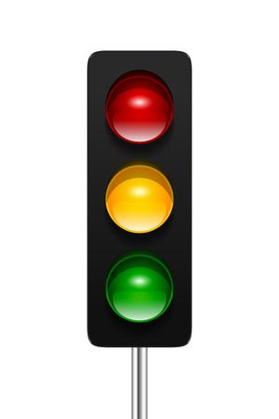

Fig.1. Traffic Automatic Control Lights

Traffic light control comes in the serious technical problem of the urban areas all over the world. This is caused by rapidly increase in the number of vehicles. The existing Traffic control system is based on the “time” which is allocated in the system. According to these times the signals are working in each lane. But in these system condition is occurs as all vehicles in lane( L1) are passed and vehicles in another lane (L2) still in waiting state because time is not over and hence signal is still red. These systems are very inefficient because they are unable to handle various simple situations which are occurs throughout the day. Major drawback is it has unnecessary waiting time and there is no facility to handle emergency vehicles. The project is designed to develop a system which perform execution based on density of vehicles(Vehicle Count).



Fig.2. Traffic Control System Using IR Sensors

After calculating the number of vehicles we will came to know in which side the density is high based on which signals will be allotted for a particular side.

This paper is concerned with the development and implementation of Sensor based Traffic Light System with Dynamic Control which in turn reduces the Average Trip Waiting Time (ATWT). It consists of IR sensors, Low Power embedded controllers, comparators and storage device[2].

The system was also developed that uses CCTV footage. The images were captured with the help of these cameras. Image processing was done but it carries edge detection of each and everything. After the image processing, according to the traffic density it allot the varying delay to only green traffic control light [3-5].

**2.1 PROBLEM STATEMENT**

The previously used system consist of IR sensors. The vehicle count was given by the sensors as they senses the vehicle. But these sensors have several disadvantages. They are incapable of distinguishing between objects that irradiate similar thermal energy levels. Infrared detectors are also expensive. As we are placing the project at all over the city signals, they cannot be widely used. Later, the system used also is not useful as it was using CCTV footage. These are the low resolution footage whose edge detection is not clear. Also this system allot the variable time only for the green traffic control light. This is not efficient.

**2.2 PROPOSED SYSTEM**

Our system is using Raspberry pi. It is used as a microcontroller which provides the signal timing based on the traffic density. And can provide facility to handle emergency vehicles automatically and efficiently. This will reduce the crime. This project also do the edge detection. The system is based on python language. This language is simple, easy to understand. The error can easily detect and removed.

1. **METHODOLOGY**

**3.1 PURPOSE OF USING RASPBERRY Pi**

In our system we have to perform multitask. For which only the controller is not good choice. We can perform single program on the microcontroller. Raspberry pie is minicomputer or a mini CPU. It can handle multiple programs running simultaneously. It is capable of doing multiple task at a time like a computer. Here we need to calculate the vehicle count for which raspberry is useful.

**3.2 WHY PYTHON**

This gives the ability to program at a faster rate than a low level language. Python syntax is very clear, so it is easy to understand program code. Python is almost identical to the simplified “pseudo-code” used by many programmers to prototype and describe their solution to other programmers.

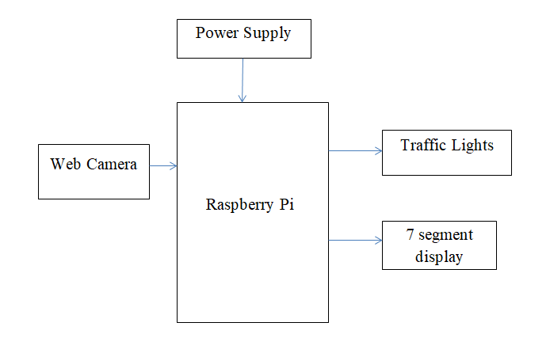

Fig. 3. Proposed System Block Diagram

**3.3 ALGORITHM STEPS**

1. The images of vehicles are captured by the web camera which is high resolution camera.
2. This images are transferred to the raspberry pi. It processes on the captured images. Through which it perform the edge detection.
3. With the help of this edge detection, system gives vehicle count. It separately count the people and vehicle through edge detection.
4. it means it check the vehicle density and probability according to which it vary the time of colored light signals in each lane.
5. If traffic density is less, the off time of red light will be less. And if traffic density is high, it will provide more time for the green light signal.
6. **CONCLUSION**

This paper presents the system proposed to control the traffic depending on the probability of the vehicle arrival at the intersection. The existing system will vary the time of the traffic light only in specific time with same rotation sequence. The proposed system varies the time of all traffic light according to traffic density.

**REFERENCES**

[1] *N. Kham, and C. Nwe, "Implementation of modem traffic light control system", International journal of scientific and research publications, Vol. 4, Issue 6, Jun. 2014.*

[2] *Y M Jagadeesh, G. Merlin Suba, S Karthik, and K Yokesh Department of Mechanical Panimalar Engineering College Chennai, India. 978-1-4673-97544/15/$31.00 ©2015 IEEE*

[3] *Taqi Tahmid1 and Eklas Hossain, Khulna University of Engineering & Technology, Dept. of EEE, Khulna 9203, Bangladesh2Oregon Tech, Department of Electrical Engineering& Renewable Energy, OR-97601, USA. “Density Based Smart Traffic Control System Using Canny Edge Detection Algorithm fo Congregating*

*Traffic Information” EICT 7-9 December 2017.*

[4] *G. Krish naiah, A. Rajani, P.Rajesh “literature review on traffic signal control system based on wireless technology” ICDER-2014.63-68*

[5] *N. Kham, and C. Nwe, "Implementation of modem traffic light control system", International journal of scientific and research publications, Vol. 4, Issue 6, Jun. 2014.*