Gesture Controlled Mouse Using Arduino
Lomesh Bhirud¹, Nitin More², Shoyeb Shekh³, Hemraj V. Dhande⁴

^{1,2,3} UG Student, B.Tech. E&TC Engg,, ⁴ Asstt. Prof.
^{1,2,3,4} E&TC Enggdept, GF’S Godavari College of Engineering, Jalgaon
¹lomeshbhirud212@gmail.com , morenitin700@gmail.com, shoyebshekh7@gmail.com, ⁴hemrajd99@gmail.com

Received on: xxxx,20xx, Revised on: xxxx,20xx, Published on: xxxx,20xx

Abstract:- In today’s era human-machine interaction is becoming widespread. So, with the introduction of new technologies the gap between machines and humans is being reduced to ease the standard of living. Gestures have played a crucial role in diminishing this gap. This project deals with design and implementation of an accelerometer based hand gesture controlled robot controlled wirelessly using a small low cost, 3-axis accelerometer. A novel algorithm for gesture identification has been developed to replace the approach of conventional controlling mechanism of robots via buttons etc. by an innovative hand gesture
based controlling. Using a microcontroller system the program has been written & executed. In the existing system, human hand movements are sensed by the robot through sensors and it follow the same. As the person moves their hand, the accelerometer also moves accordingly sensor displaces and this sensor senses the parameter according to the position of hand.

Keywords – Low-Cost Automation (LCA), combination sorting, PLC, ladder diagram

1. INTRODUCTION
Computer technology has tremendously grown over the past decade and has become a necessary part of everyday live. The primary computer accessory for Human Computer Interaction (HCI) is the mouse [1]. The mouse is not suitable for HCI in some real life situations, such as

with Human Robot Interaction (HRI). There have been many researches on alternative methods to the computer mouse for HCI. The most natural and intuitive technique for HCI, that is a viable replacement for the computer mouse is with the use of hand gestures.[2] This project is therefore aimed at investigating and developing a Computer Control (CC) system using hand gestures.

2. LITERATURE SURVEY
The main goal of gesture recognition research is creation of a system that can identify specific human hand gestures and use them to convey information or for device control as well as applications control. Hand Gesture Recognition System is a branch of Human Computer Interaction in which Human hand gestures are recognized by the computer system and then perform pre-defined task as per the application for controlling software as well as hardware.

2.1 Problem Statement
Mouse free: An appealing option for replacing primitive human computer interaction (HCI) with the use of touchpad or mouse is the Vision-Based Human Computer Interaction through Real-Time Hand Tracking and Gesture Recognition Vision-Based interaction. The proposed system makes use of the webcam for tracking the user’s hand and to recognize the gestures for the purpose of interaction with the system. The contributions of our work will be to implement a system for hand tracking and simple gesture recognition in real time. Many researchers in the field of robotics and human computer interaction have tried to control mouse movement using video devices. However, different methods were used to make a clicking event. A click of the mouse button was evolved by defining a screen such that a click occurred when a user passed his hand over the surface. Another approach was developed by Chu-Feng Lien. Only the finger-tips to be used to control the mouse cursor movements. The clicks were based on image density, and the user needed to hold the mouse cursor on the desired spot for a short period of time. Paul et al, used still another mechanism to click. They used the motion of the thumb from a ‘thumbs-up’ position to a fist to mark a clicking event. Movement of the hand while making a special hand gesture moved the mouse pointer. The cost is relatively changed with modification in the system & improving size of conveyer & adding sensor.
2.2 Proposed Method/System
Instrumented /Data Glove approach: Instrumented data glove approach involves the use of sensor devices to recognize the hand gestures. This easily provides exact coordinates of palm and finger’s location and orientation, and helps in hand recognition. Where logic is controlled by programmable logic controller.

3. BLOCK DIAGRAM & CIRCUIT DIAGRAM
3.1 Block Diagram
Here the conveyer is used to pass the object in front of sensor which is drive by DC motor.
Colored Markers approaches: In order to direct the procedure of tracking the hand and locating the palm and fingers colored markers are gloves that are worn by the human hand. It consists of some colors in order to direct, which provide the ability to extract geometric features necessary to form hand shape.

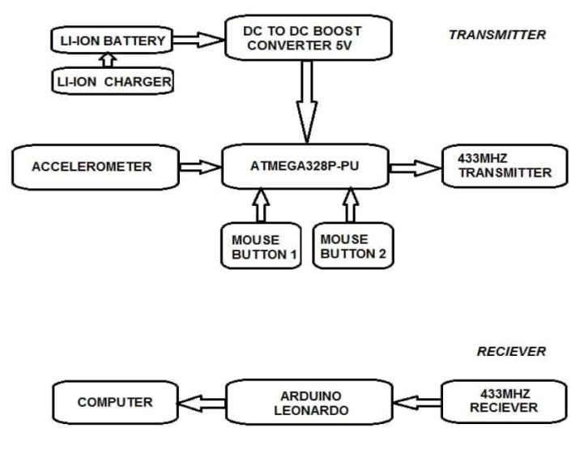
Fig 1- Block Diagram of transceiver

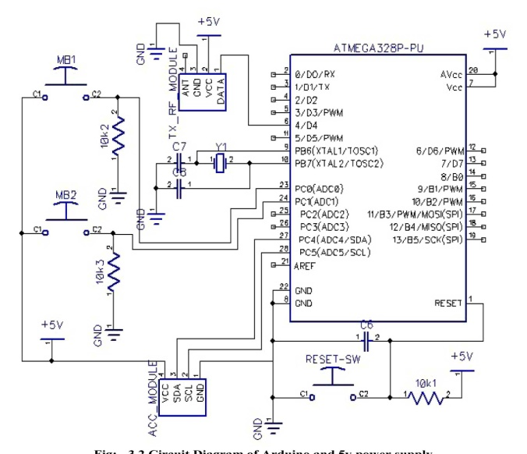
Fig 2- Circuit Diagram of Arduino and 5v power supply

4. HARDWARE COMPONENT
The Arduino Uno is a microcontroller board based on the ATmega328. It has 14 digital input/output pins (of which 6 can be used as PWM outputs), 6 analog inputs, a 16 MHz crystal oscillator, a USB connection, a power jack, an ICSP header, and a reset button. It contains everything needed to support the microcontroller; simply connect it to a computer with a USB cable or power it with a AC-to-DC adapter or battery to get started. The Uno differs from all
preceding boards in that it does not use the FTDI USB-to-serial driver chip. Instead, it features the Atmega8U2 programmed as a USB-to serial converter. "Uno" means one in Italian and is named to mark the upcoming release of Arduino 1.0. The Uno and version1.0 will be the reference versions of Arduino, moving forward. The Uno is the latest in a series of USB Arduino boards, and the reference model for the Arduino platform.

5. WORKING
Our design plan comprises of two principle parts: a glove and a microcontroller board (Arduino Uno). Operation of our gadget starts with the glove. A client wearing the glove can utilize hand tilt placement and button presses to work the gloves. As the hand tilts, the values of the X, and Y-axis from the accelerometer are changing and it an be read in the form the accelerometer are changing and it can be read the form of analog inputs of the Arduino microcontroller board. The glove detects these client activities through two sorts of sensors: accelerometer and push button switches. After the Arduino (glove’s Microcontroller) forms the information by processing the input data, it transmits the data serially to the host PC. The Mouse Glove uses Arduino Uno microcontroller board that is connected serially to the host PC via USB wire. ADXL335 microcontroller sense physical tilt and sends the analog output to the Arduino. For sensing left and right mouse clicks it uses push button switches that are connected to pull-up resistor.

6. ADVANTAGES, DISADVANTAGES, APPLICATION AND FUTURE SCOPE

6.1 Advantages
• Portable
• Cost effective
• Open source software
• Data access directly from the machine to the real time
6.2 Disadvantages
• Post processing can occur.
• Hardware limitation on carrying everywhere
6.3 Application
Gesture recognition, technology, is achieving rapid market adoption as it evolves and matures. However, gesture recognition as a user interface scheme also applies to a wide range of applications beyond consumer electronics. In our project is very useful as we can use our gestures for controlling the cursor of the mouse.

7. CONCLUSION
As per the objective a portable embedded device consisting of tri-axial accelerometer, microcontroller (ATMEGA328P-PU & ATMEGA324U) and wireless communication module has been built and tested. The acceleration signals measured from the accelerometer are transmitted to the computer via USB. In this project, MEMS accelerometer measures the acceleration of the signal in three co-ordinates such as x-axis, y-axis, and z-axis. An executable file should be installed in PC. A required COM port is selected and enabled. Then moving the accelerometer will also produce the movement of the computer cursor. This system could be useful in presentations and to reduce work space.

REFERENCES
[1] Prof. K. A. Patil, Prof. N. R. Kale, ,Information Computing and Communication, 978-1-5090-0467-6/16/$31.00,IEEE 2016.
[2] R. Nageswara Rao and B.Sridhar, 978-1- 5386-0807-4/18/$31.00,IEEE (ICISC 2018).

