ONLINE EVENT MANAGEMENT SYSTEM

‘Raksha Ghutke’, ‘Minakshi Waghmare’, ‘Ruby Singh’
‘Supriya Narote’, ‘Payal Shende’

Assistant Professor, Nikita Hatwar

‘Information Technology, Priyadarshini College Of Engineering Nagpur,India,440019’

ABSTRACT:
Online event management system is a project (Website) that serves the functionality of an event manager. it is a crucial factor and fast growing concept need to manage all type of events such as Wedding Event, Corporate Event and Birthday Event etc. In this project we are installing Xampp server on a machine, All the machines in the LAN can access this server to use this website.
Registered user can login and new user can register easily. The system helps in the management of events, users and the aspects related to them. This project provides most basic functionality required for an events. Various types of events such as Wedding, Dance Shows, Birthday Parties, College Festivals, etc. can be managing in one website. When user login the system allows user to select date and time of event, place and the event equipment. All the data stores in the databases and the user getting booking event receipt with booking number. After that administrator (website owner) and their team going to interact with the user as per booked event. Keywords- User, Admin, Events, Book, Event Management, Databases.

Introduction:

Event management is an application to manage and celebrating events. Proposed work involves study of identifying the target of budget, cost and analysis. Post event analysis and ensuring a return on investment have become significant drivers for the event industry. Online event management system is a software project that serves the functionality of an event manager. User can select event from event list. Event Management System is very helpful for celebrate events. User have to register, after registering, user can login, after login, event details including name ,contact, address, venue of the event, date, event conducting time, cost of events etc. these all process should be follow for event booking.

LITERATURE SURVEY:

We have studied several papers based on event management system. First paper which we have studied is named as “ Special Event Management And Event Marketing: A Case Study Of TKBL all-star 2011” which was published by L. McCathie and K. Michael, Lung-Chuang Wang, Roozbeh Derakhshan. In this paper aims to understand the how to manage and market the events successfully satisfied participants[1].
The second paper named as “Event Management System” Which is published by Prof. Lee, M. J., & Back, K. J. (2005).This paper is introduced the Event Manage and development of festivals, events and conferences. The system allow registered user login and new user are allowed to register on application[2].
The third paper named as “Smart Event Management System” which is published by Assistant Prof Neuendorf, K. A. (2002), and Getz, D. (2012). This paper introduced a system which will be computerized and developed using advanced language as Content Management System[3].
.

PROPOSED SYSTEM:

The proposed system is computerized and has been developed using advance language i.e. Content Management System therefore it gives more facilities than existing system. Also it providing bootstrap facilities which means user can open website on their cell phones too. It provides quick access to any data. In this system user have to fill the information only once and then it get linked with all files.
This reduces the workload of user and it is also a time saving process. The proposed system consists of packages with the different category such as catering, decoration, DJ sounds, makeup artist services etc. and updating the records at regular interval. This web based application system can be implemented in hotels, clubs for booking events. This system is effective and time saving cost of the user and administrator easier. It is efficient to use and easy to work on it.

METHEDOLOGY
It consists of various modules dealing with managing customer and employee information, managing event information, managing services, e-card creation and website for status check. The first module of the project is customer opens the website and select the which type of event wants to celebrate ,then search for venues after selecting venue which type of decoration he wants can select from decoration services and in budget can also select catering package after selecting all the things which are required one by one as selected it added automatically in cart and generate the bill user can pay 40% payment online balance payment can be pay after

CLASS DIAGRAM:

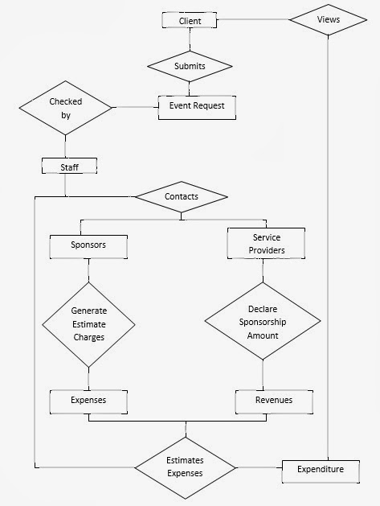

APPLICATIONS:

It can be used to organizing events in school & colleges.

It can be used for celebrate birthday , wedding or any kind of events.

It can be used for business industry also to celebrate events as conferences.

SNAPSHOTS:

Home page:-

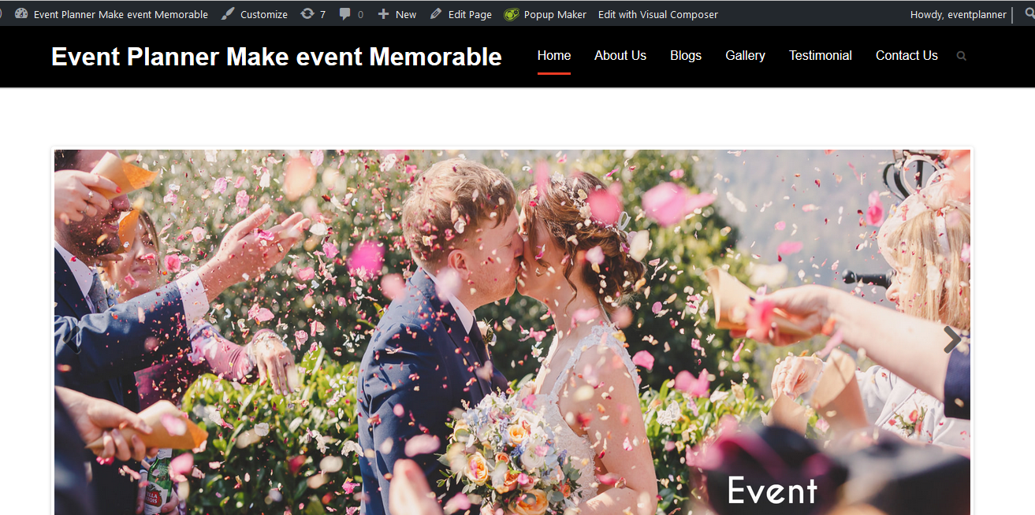

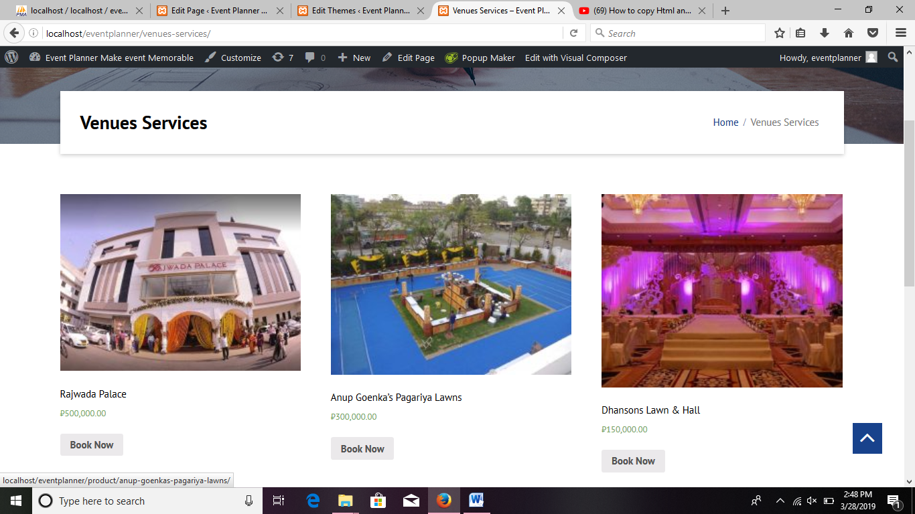

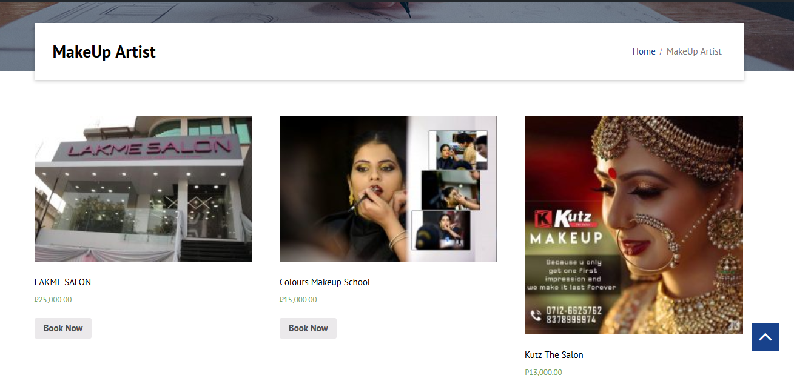
CONCLUSION:

This project will help the respective events to manage and automate the entire database in the network. This project will definitely reduce the human efforts and makes the task of user, customer and administrator easier. Thus keeping in mind the advantages and applications. we are developing an Event management website which has total management control of customer and employee and respective services of different events.

Acknowledgment:
The authors sincerely thank Prof. Nikita Hatwar for her Expert guidance and support throughout the work. The Authors also thank college of Information Technology and Engineering and RTMNU University for the infrastructure and Support provided.

References:
[1]. L. McCathie and K. Michael, “Is it the End of Barcodes in Supply Chain Management?”,Proceedings of the Collaborative Electronic Commerce Technology and Research Conference LatAm, 2005.

[2]. Lung-Chuang Wang, “Enhancing construction quality inspection and managementusing FID technology”, Journal Automation in Construction, Elsevier, pp. 468-469, 2008.

[3]. RoozbehDerakhshan, Maria E. Orlowska and Xue Li, “RFID Data Management: Challenges and Opportunities”, IEEE International Conference on RFID, 2007.

[4]. Fauzan Saeed, Mustafa Rashid, "Integrating Classical Encryption with Modern Technique", IJCSNS International Journal of Computer Science and Network Security, VOL.10 No.5, May 2010.

[5]. Getz, D. (2012). Event studies: Discourses and future directions. Event Management, 16, 171-187.

[6]. Jones, C. (2012). Events and festivals: Fit for the future? Event Management, 16, 107-118. Lee, M. J., & Back, K. J. (2005). A review of convention and meeting management research 1990-2003: Identification of statistical methods and subject areas. Journal of Convention & Event Tourism, 7, 1-20.

[7]. Neuendorf, K. A. (2002). The content analysis guidebook. Thousand Oaks, CA: Sage. Woelfel, J. (1993). Artificial neural networks in policy research: A current assessment. Journal of Communication, 43, 63-80.

