Design, Analysis and Optimization of Two Wheeler Alloy Wheel

Rohti Yadav¹, Dr. Bharat Chede², Swapnil Chaudhary ³

¹M-Tech Student, ²Professor, ³Assistance Professor
Mechanical Engineering, Wainganga college of Engineering and management, Nagpur.

rohit.premyadav@gmail.com

Received on: 05 April, 2022 Revised on: 11 May, 2022, Published on: 13 May,2022

Abstract: - Now the daily increase in demand for vehicle at a lower cost is the need for vehicle manufacture. Expectations about durability, efficiency and cost are growing rapidly with customers. Parts designee two wheeler load (weight) and minimize efficiency. Alloy wheels take a large number of vehicles and are help by a suspensions system, which can rearranged and adjusted to take low weight or thus costly. The existing Alloy wheel component is available on the re-designed market and the CAD model using the CATIA software. Finite Element Discretization and Analysis was performed use the ANSYS software. F E A assisted in identifying locations of high strain in the segment and deiscribe a fixed area and a well-designed model obtained through topology optimization. Weight measurement will done in areas were strain is high identified by F E A software. Adjustments are made to mount part of UTM. Direct loading simulating direct communication leads to cantilever situations is achieved using UTM. Processing is performed to extract additional matals from the components. Comparatively analysis was performed between F E A and experiment strain.

I -INTRODUCTION
In 60’s were alloy wheel start developed to the need for subject enthusiasts who was continually look for a position in the styling and performance. It has an unorganized startup at the time. Since its overtake by Original Equipment Manufacturer, the two wheeler alloy wheel market has been growing slowly. Now days, thank to more re-fine and ecofriendly customers, the employment of alloy wheels is becoming increasing appropriately. When demand is increasing then new development also been increases, to provide a with large design style take superior technology and production processes. The widely accept the process to cart wheel production is to pass two strength test, especially a fatigue check and test for existing fatigue. Since the local unit of alloy wheels is designed for a variety of styles and has many more complex’s features than conventional steel wheels i.e. spoke wheel, it is quit possible to assess fatiguelife using abstract analysis techniques. Wheel has a very important role in car protection and ensure that the durability. The automotive industry events had a pro-found the impact on look, therefore the production is start of the wheels. The method of loading the wheels can be complicate, further upgrades and a threatening style can be achieved as long as the loading is very understandable. In order to obtain high wheel alignment, 2 requires the required unit. Accurate loading information and consequently allowable stresses and mechanical properties of material components, production processes and service conditions. Other danger is to use a FEM to get the pressure in the wheel rims and to test various style solutions.
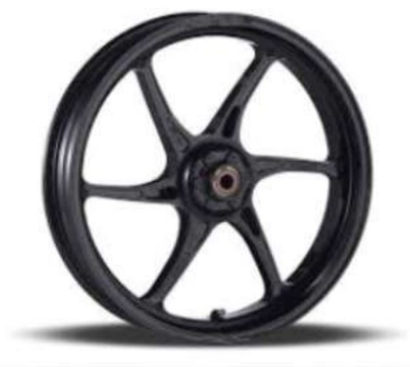

Fig 1- Two wheeler alloy wheel
Made model current -wheeler alloy wheel alloy in CATIA software. Program determined pressure and deformation using Ansys software the usage of static structural analysis created model designed the use of topological optimization approach a prepared model used to decide stress and deformation machine of current wheel as a organized model obtained from the development of topology the vicinity is designed and constructed fixture to preserve the wheel firmly inside the take a look at experimental exams are accomplished and the corresponding outcomes are obtained
II -PROBLEM STATEMENT

The wheel is one of the most important components of a vehicle. Currently, the wheel incorporates excess fabric, which results in a growth in automobile weight. It without delay affects miles and expenses. On this thesis, modeling the prevailing wheel within the CAD software program and reading it to determine the structural stresses and deformation of CAE software. Then the use of Topology optimization extra material can be eliminated. It changed into also evaluated by assessing structural pressure and the results were related to analytical results.
III-METHODOLOGY
Enhancements are made in an opportunity, analytical and performance-based totally approach to FEA testing and analysis. The present -wheeler alloy wheel changed into taken from the market. Superior objects had been eliminated from the organized place through adding some holes. it is designed and production the fixture the scale of the wheel mounting on UTM. Vertical loading simulating direct communication ends in cantilever conditions are executed the usage of UTM. And information is being accrued. in the FEA analysis, CAD modeling changed into carried out on an existing CATIA V5 wheel, follow materials and belongings for discretization turned into completed from the cad model inserts the direct load and boundary circumstance at the wheel using precise boundaries. The effects pop out inside the shape of strain plots. In those consequences the improvement of topology is carried out in those outcomes so that you can get rid of different routine analyzes inside the form of a comparative shape of stress outcomes and to finish outcomes,
IV- CAD MODEL OF 2-WHEELER ALLOY WHEEL
The design of the CAD wheel is adjusted based on the common names for the outer space and the wheel hub. figure. Demonstrates the CAD design of pre-assembled rim wheels the cloth used is die casted aluminum. The elements used on this alloy consist of silicon, iron, manganese, copper, magnesium, and zinc.

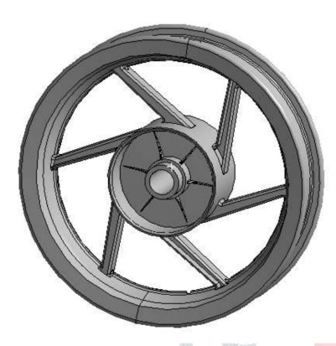
Fig 2- CAD model in CATIA
MESH
The existing 2-wheel alloy design is made with CATIA software and F E A analysis is worked using ANSYS software to determine the stress, strain and Topology optimization using the ANSYS topology optimization module. Initially the model designed for CATIA was import via ANSYS as the above image mentioned for analysis.
Meshing is a fashionable, clever, automated product. The producer has the most appropriate mesh for correct, efficient Multiphasic answers. A mesh this is nicely appropriate to a specific evaluation may be generated with a unmarried mouse click on on all components of the model. Complete controls on the alternatives used to supply the mesh are available to the professional user who desires to music them nicely. The identical processing strength is robotically used to reduce the time you have to anticipate mesh production. Growing the maximum suitable mesh is the basis of engineering simulation. ANSYS Meshing knows the form of answers with a view to be utilized in a task and has the proper conditions to create the most appropriate criteria. ANSYS Meshing is mechanically integrated with every solution in the ANSYS Workbench region. The FE model is optimized for 36 ° of its circumference as the closing element may be pondered precisely. Required modifications also can be made within the equal section. Tetrahedral elements are used for modeling.

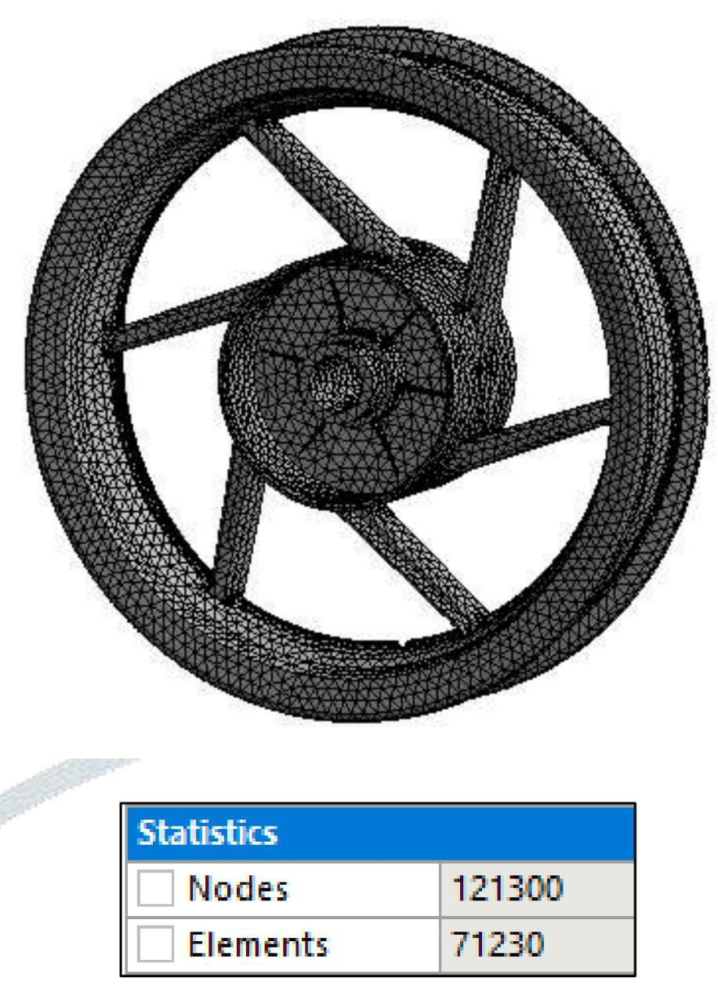
Fig 3- Meshing in ANSYS Softwaer
BOUNDARY CONDITION
A conditional situation of the version is the adjustment of the recognized displacement value or partner load. You may set load or displacement in a specific node but now not each. The primary loading types available in FEA include force, stress, and temperature. This can be carried out to points, floor, edges, nodes, and elements or remotely eliminated from a function. In the 2-wheeler alloy wheel, the outer rim of the hub is fixed because it stands. The loading within the internal circle is used as described above and the tire strain is implemented to the rim. Bendy assist is used on the edge help and strain of tire is 30psi is applied from in zero. 206mpa. the load of the motorcycle is considered to be 110 kg so, the load of every wheel is 55kg in that 30% absorbed through suspension i.e weight applied is 1650N.
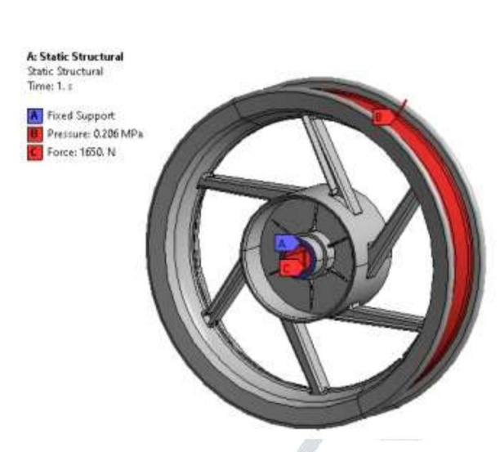
Fig 4-Boundary condition of alloy wheel
TOTAL DEFORMATION
Total deterioration and deformation is generally a called in FEM limited regardless of software is used. Directional modification can defined as system shift in a specific axis or direction defined by the user. Total degradation is the sum of the vector of all direct transitions of systems.
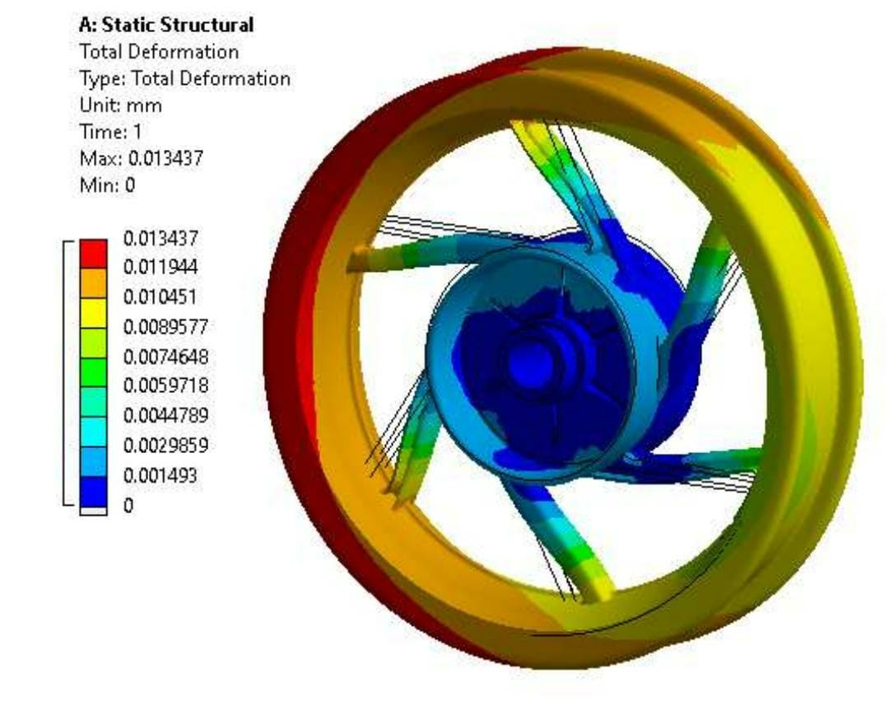

Fig 5- Result of total deformation
The maxi deformation is 0.0134 mm is determined by the element present in the use of the boundary condition as mentioned in the section above.
EQUIVALENT STRESS RESULTS
The max equivalentstress is reflected in 7.45 MPa and the available material in the use of the boundary condition as mentioned in the section above. It's far located that the layout is safe because the strain exceeds the yield of aluminum alloy with a strength of approximately 280 MPa and a very last energy of 310 MPa.

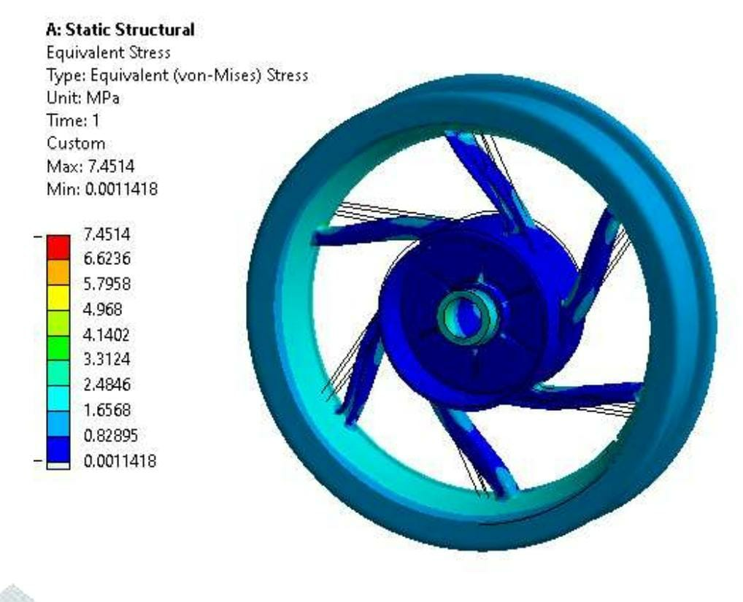
Fig 6-Result of Equivalent stress for existing material
TOPOLOGY TECHNIQUE FOR OPTIMIZTION
The function in this paper makes use of the grid perturbation approach. Topology development is extensively used in recent studies to locate first, and sometimes absolutely progressive, variations (i.e., objective work and limitations).
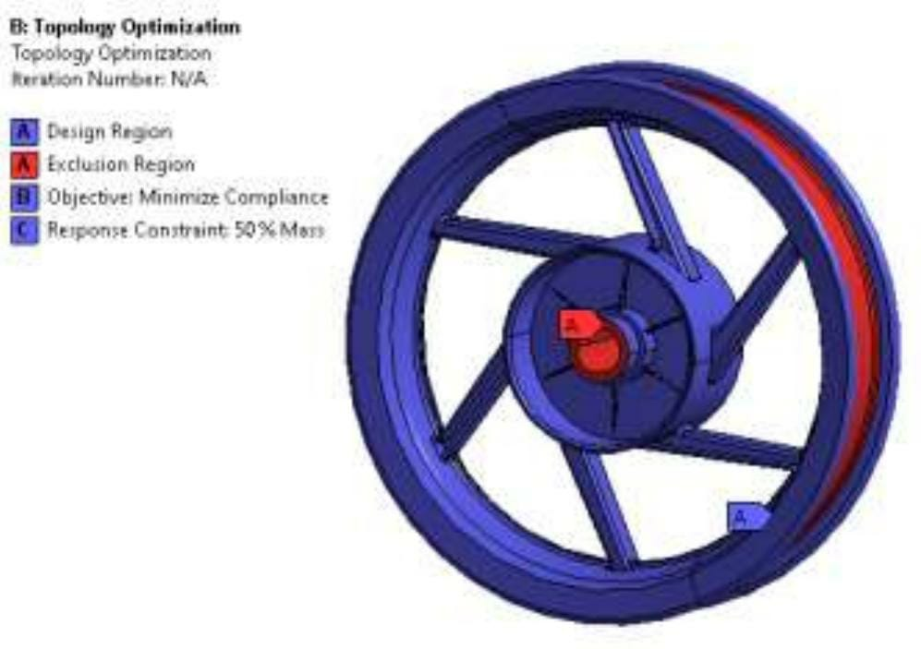Fig7-Boundary condition of topology optimization

Within the ANSYS a topology optimization module is used related to static structure evaluation to determine boundary condition and end result for optimization. to start with the blue area offers itself as a design area and the crimson vicinity as an exclusion region thinking about the boundary condition i.e. strain, load and fixed support.

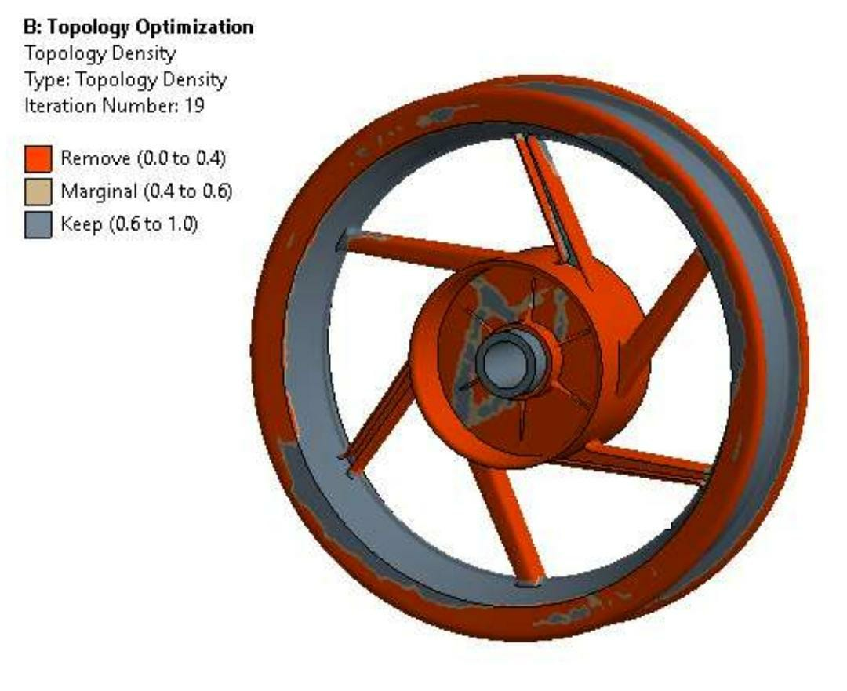
Fig 8-Red region indicate for material removal area.

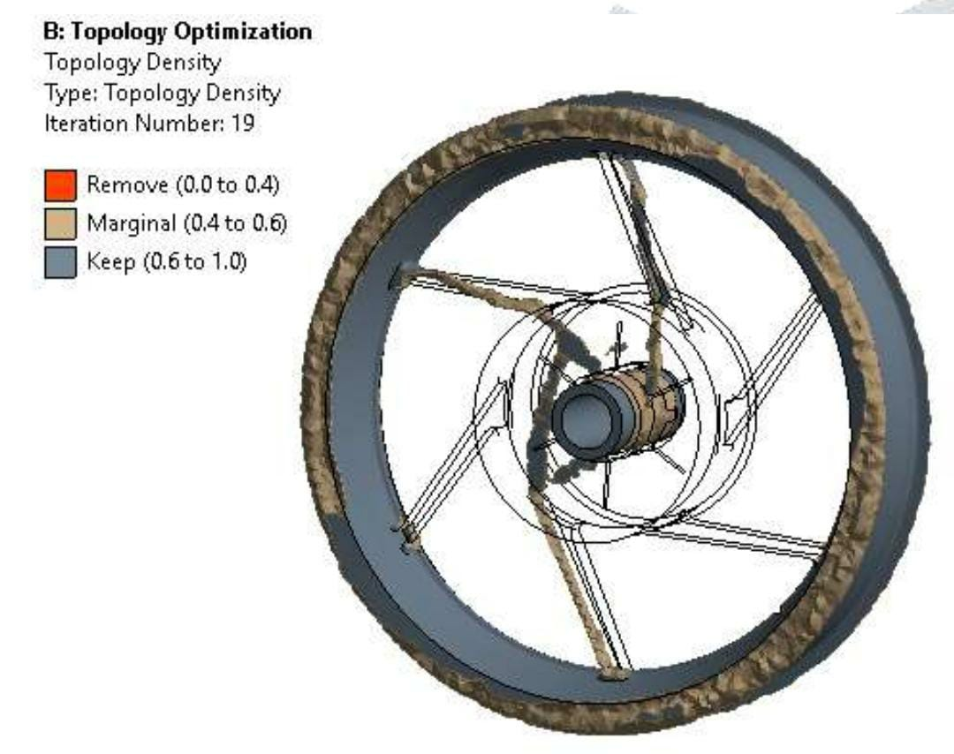
Fig 9- Optimization model of existing 2-wheeler alloy wheel
After the perform topology optimization the red shade of the location shows the cast-off area and margin and keeps the object to avoid removal of items in that. Removed extra material with an appropriate shape and geometry of the required size within the shape and size and re-analysis is carried out at the design designed to test stress intensity on factor.
V- MATERIAL REMOVING PROCESS
The drilling process material is removed with different diameter.

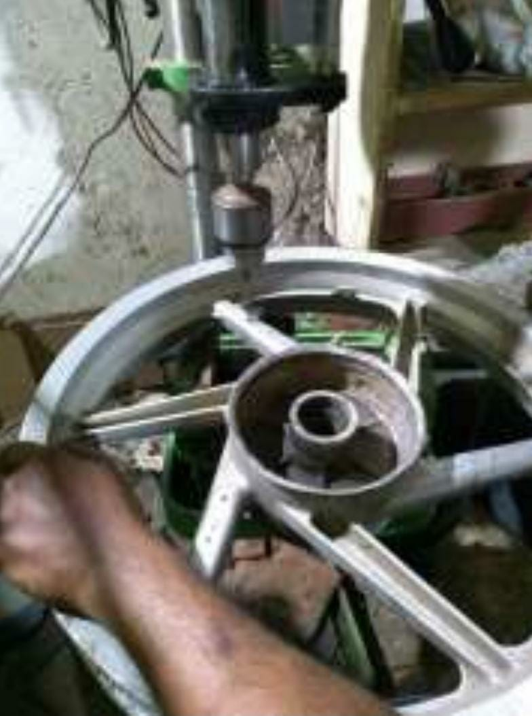
Fig 10- Material removing process.

VI- OPTIMIZED DESIGN
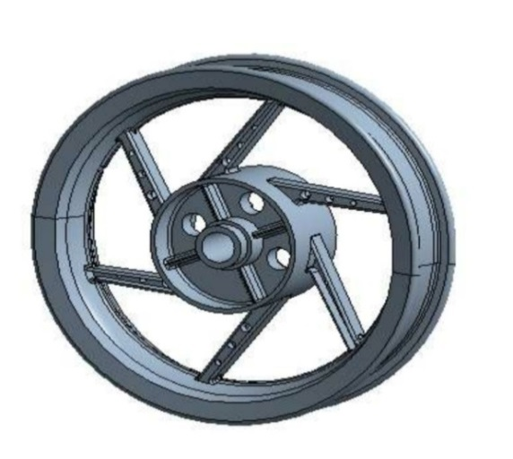
Fig 10-optimized wheel design
In the wheel design of holes 10mm, 8mm and 6 mm wide and 22 mm medium holes are drilled in the topology area.
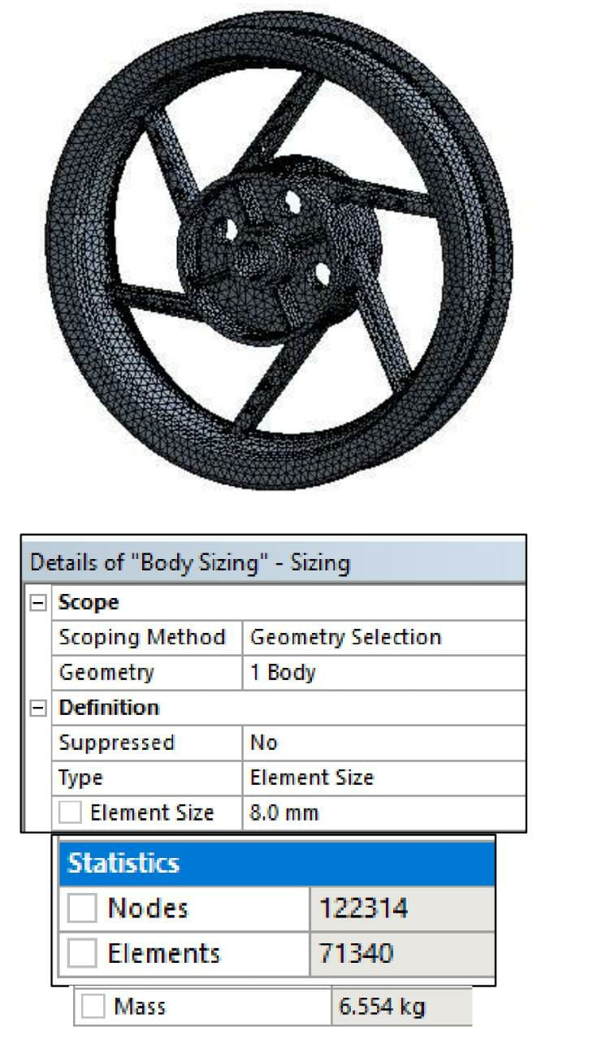
In the 2nd stage of FEA , the tetrahedral meshing is select by mesh 8mm . node and element in the design is 122314 and 71340. In this meshing this is solved on node so mesh size is important for stress and strain
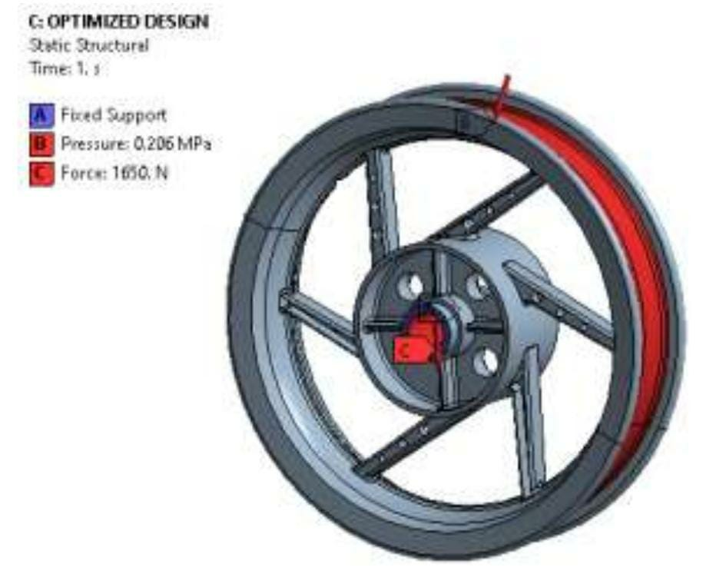Fig 11- Bouandary condition on optimized design
In the alloy wheel the exterior rim of the hub is fix as it stand. The loading in the inside circle is used as describe above and the wheel pressure is applied to the alloy wheel. Fixed support is used on the edge. Wheel pressure of about 30 psi is applied at a rate of 0.206 MPa. The weight of the bike is estimated to be about 110 kg so, the weight of each wheel is 55 kg when 30% is absorbed suspension so 30% of weight is used 1650 N. After the use of the boundary condition FEA analysis is resolved to decide stress and deformation
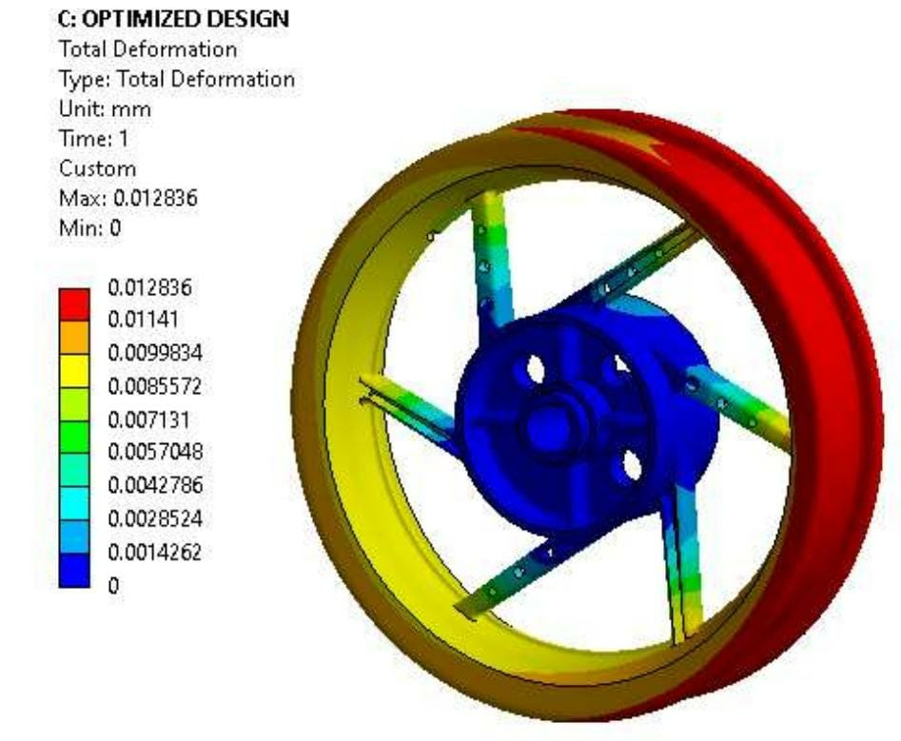
Fig 12 -Result total deformation of optimized design
The maxi deformation sizes of 0.012mm also show in the material available in the use of the boundary condition as mentioned in the section above.
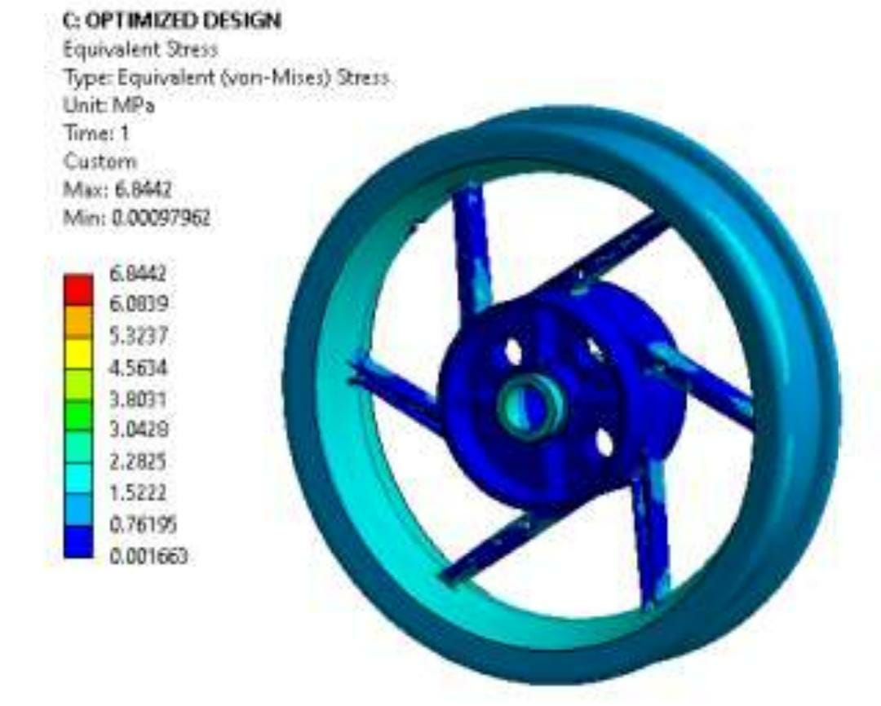
Fig 13- Result of Equivalent stress optimized design
The maximum equivalent stress is shown approximately 6.84MPa for the material present in the boundary condition application as mentioned in the section above. It is observed that the design is safe as the stress is not beyond yield strength of aluminum alloy with a power of approximately 280MPa and a ultimate strength of 310MPa.
VII - EXPERIMENTAL TESTING FEA

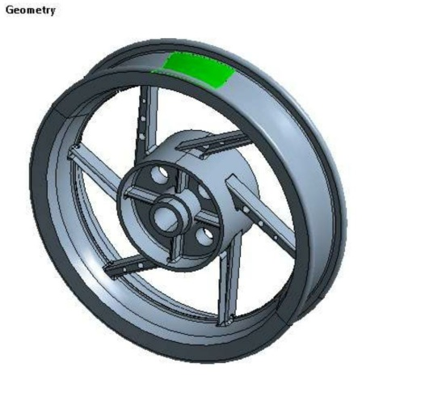
FORCE(F) = PRESSURE(P) X AREA(A)
F = 0.201MPa x 5107.5mm2
F = 1052N
During the test the 30 psi wheel pressure in the specified section is used in form of the force by multiplying the pressure to determine the force with a position.
This force is then applied to the ANSYS to detect strain and after determination of maximum strain the area strain gauge, gauge is attached to the area to ensure testing is performed using 1052 N force with UTM upper arm and recording difficulty using DEWESOF software.

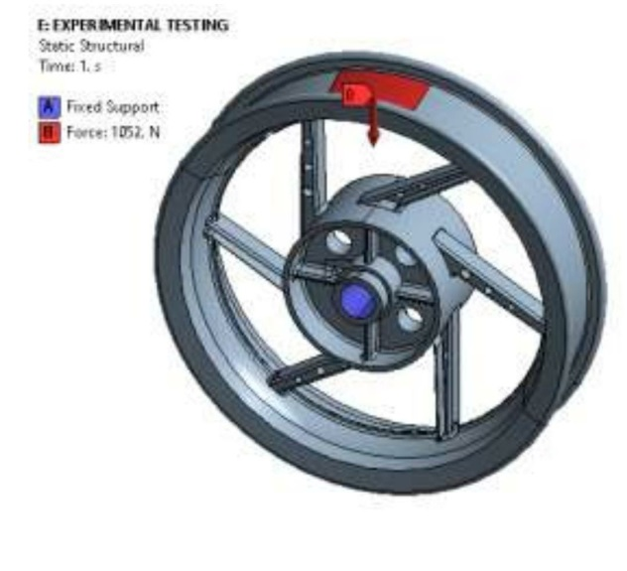
Fig 14- Boundary condition

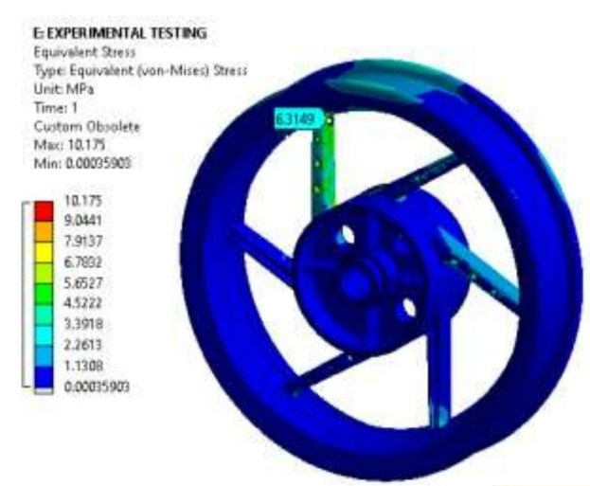
Fig 15- Result equivalent stress

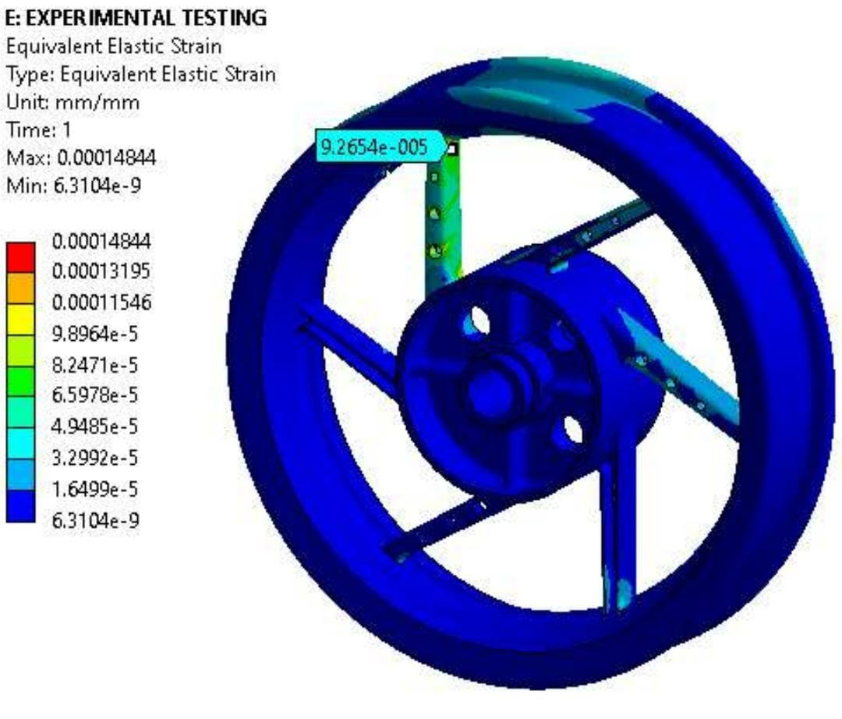
Fig16- Result equivalent strain.
Strain is observed 0.09265microns using FEA.
VIII- CONCLUSION
- In the design of Two wheeler allow wheel, The design is divided in to two section or two part. That is design space and nondesign space. In nondesign space it cannot be change or modified.
- In the design part of wheel, there have optimized the shape and weight of the wheel. The wheel has taken least quantity of material and reduces the cost of manufacturing.
- Two wheeler alloy wheel numerical analysis of the existing is done with common materials with the help of ANSYS software.
- Improved design of alloy wheels found in the topology optimization techniques.
- The weight of the two wheeler alloy wheel rim is reduce from 7.227 Kg to 6.554 Kg using the topology method. The design of the cross section of the arm is simple to production.
- After optimized the two wheeler alloy wheel, Reduce the vertical load 1650N to 1052N and Maximum equivalent stress is decreased to 7.45Mpa to 6.84Mpa. that is less than the yield stress of material i,e. 280Mpa
- After optimized Strain is measured of 92.65microns by numerical and experimental testing respectively.

REFERENCES

[1] Madhu K Saet, Ravi Prakash Mb, & Somashekar H Kc ”Structural Analysis and Optimization of Two Wheeler Alloy Wheel by Using FEA Approach”
[2] Sandeep Kumar, T. K. Kundra and S. V. Modakre ”Model Updating Studies on a Two Wheeler Chassis”,
[3] Poonam Meshram , Ashish Sinha ”design & optimization of alloy wheel rim using ansys”,
[4] M. Saran Theja, M. Vamsi Krishna ”Structural and Fatigue Analysis of Two Wheeler Lighter Weight Alloy Wheel”,
[5] Sourav Das, “Design and Weight Optimization of Aluminium Alloy Wheel” International Journal of Scientific and Research Publications, Volume 4, Issue
[6] 6, June 2014 ISSN 2250-3153. 6. X Jiang, R Lyu1, Y Fukushima, M Otake and D Y Ju ”Lightweight design and analysis of automobile wheel based on bending and radial loads”,
[7] Daniel Antony C, Prince Jerome Christopher J ”Design and Analysis of Two Wheeler Alloy Wheel Rim Using Composite Materials”
[8] J.L.Miren Kisshan, K.Sankara Narayanan, Ben Mathew Augustine, Dr. D.Vijayaganapathy ”design and analysis of wheel rim”,
[9] R.Masilamani, N.V.Dhandapani, R.Ratheesh Kumar, Nived Devadas, M.Elangovan Design Modification And Optimization of Vehicle Rim using Finite Element Analysis – A Pot Hole Approach”,
[10] S. Chaitanya, and B.V.RamanaMurty, “Mass Optimization of Automobile Wheel Rim” International Journal of Engineering Trends and Technology (IJETT) – Volume 26 Number 3- August 2015.
[11] Ch. P. V. Ravi Kumar, and R. Satya Meher, “Topology Optimization of Aluminium Alloy Wheel”, International Journal of Modern Engineering Research (IJMER), Vol. 3, Issue. 3, May.-June. 2013 pp-1548-1553 ISSN: 2249-6645
[12] TurakaVenkateswara Rao, and KandulaDeepthi, “Design & Optimization of a Rim Using Finite Element Analysis”, International Journal of Computational Engineering Research (IJCER), ISSN (e): 2250 – 3005, Vol, 04, Issue, 10, October – 2014.
[13] Mr. Sushant K. Bawne, and Prof. Y. L. Yenarkar, “Optimization Of Car Rim”, International Journal of Engineering Research and Applications, ISSN: 2248-9622, Vol. 5, Issue 10, (Part - 2) October 2015.
[14] BGN Satya prasad, M Anil kumar, “Topology Optimization of Alloy Wheel”, Altair Technology Conference, India-2013.
[15] D. H. Burande, and T. N. Kazi, “Fatigue Analysis of Alloy Wheel for Passenger Car under Radial Load”, International Journal of Engineering Research and General Science Volume 4, Issue 2, March-April, 2016, ISSN 2091- 2730.
[16] H. N. Kale, and Dr. C. L. Dhamejani, “COMPARATIVE STUDY OF WHEEL RIM MATERIALS”, IJARIIE-ISSN(O)-2395-4396, Vol-1 Issue-5 2015.
[17] Hypermesh Help Desk for Topology Optimization.
[18] Dassault Systems user manual

